a

**SECRETARIAT OF THE PACIFIC COMMUNITY**

**GLOBAL CLIMATE CHANGE ALLIANCE:**

**PACIFIC SMALL ISLAND STATES PROJECT**

**FUNDED BY THE EUROPEAN UNION**

**REPORT ON YAP CAPACITY DEVELOPMENT IN PROPOSAL PREPARATION USING THE LOGICAL FRAMEWORK APPROACH WORKSHOP**

**17-20 MARCH 2014**

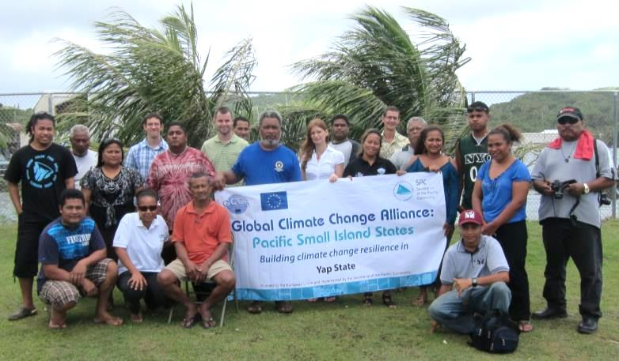



**Introduction**

The Global Climate Change Alliance: Pacific Small Island States (GCCA: PSIS) project is funded by the European Union (EU) and implemented by the Secretariat of the Pacific Community (SPC) in collaboration with the Secretariat of the Pacific Regional Environment Programme (SPREP). The project budget is €11.4 million. The implementation period for the GCCA: PSIS project is from the date of signature of the agreement, 19 July 2011, to 19 November 2014.

The overall objective of the EU funded GCCA: PSIS project is to support the governments of nine Pacific smaller island states, namely Cook Islands, Federated States of Micronesia (FSM), Nauru, Marshall Islands, Niue, Kiribati, Palau, Tonga and Tuvalu, in their efforts to tackle the adverse effects of climate change. The purpose of the project is to promote long term strategies and approaches to adaptation planning and pave the way for more effective and coordinated aid delivery on climate change at the national and regional level.

The project approach is to assist the nine countries design and implement practical on-the-ground climate change adaptation projects in conjunction with mainstreaming climate change into line ministries and national development plans; thereby helping countries move from an *ad hoc* project-by-project approach towards a programmatic approach underpinning an entire sector. This has the added advantage of helping countries better position themselves to access and benefit from new sources and modalities of climate change funding, e.g. national and sector budget support.

**GCCA: PSIS Capacity development in proposal preparation using the logical framework approach Project (‘LFA training’) in Yap.**

Following a regional workshop on Climate Finance and Proposal Preparation held in Apia, Samoa, 26 – 27 October 2012, and supported by the Asia-Pacific Adaptation Network (APAN), Secretariat of the Pacific Regional Environment Program (SPREP) and SPC, all of the countries involved in the GCCA: PSIS project expressed their interest in having a national training workshop on project proposal preparation using the logical framework approach. FSM made a request to the GCCA: PSIS project to hold separate trainings in Yap, Kosrae and Chuuk in addition to the national training held in Pohnpei in February 2014. This particular training in Yap responds to that expressed need.

The Coping with Climate Change in the Pacific Island Region program (CCCPIR) implemented in partnership with Deutsche Gesellschaftfür Internationale Zusammenarbeit (GIZ) on behalf of the German Federal Ministry for Economic Cooperation and Development (BMZ) has assisted with the provision of logistical support for the training in Yap.

The training provides a valuable opportunity to strengthen national government staff to develop successful and integrated climate change adaptation project proposals. This will allow PSIS and donors to work together to ensure a more effective and coordinated aid delivery to address climate change at the national and regional level.

The Yap training workshop was delivered over 4 days (17-20 March 2014), with additional mentoring after hours on the 20th and on 21st March 2014. Pacific Research and Evaluation Associates (PREA) were contracted to deliver the LFA training, based on the resources that they had previously developed and piloted in the Cooks Islands. The workshop was held at the Yap Small Business Centre. The training was attended by 18 participants.

The training made use of a donor directory (Donors for Climate Change Adaptation in the Pacific) developed for SPC and SPREP. PREA also researched additional donors active in the Pacific region who support PSIS. All relevant training resources were provided to participants in hardcopy with an electronic copy provided on a USB stick for all participants. Additional outputs (problem tree, solution tree and logframe matrix) created during the workshop were also included on the USB stick.

The key topics covered during the LFA training include a background on the project management cycle, a detailed look of the logical framework approach, proposal writing (informed by the LFA) and a brief summary of climate change donors active in the Pacific region. A detailed delivery plan is included in Annex 1.

The LFA training workshop was organised by SPC through Ms Victorina Loyola-Joab(SPC GCCA: PSIS) with support from the Federated States of Micronesia national government through Ms Belinda Hadley (SPC FSM National Coordinator, OEEM) and the Yap state Government’s Resources and Development department through Mr. John Sohlith (Yap State Deputy Director for R&D). Lt. Governor Mr Tony Tareg welcomed participants and officially opened the workshop. Ms Victorina Loyola-Joab also provided opening remarks, providing context for the training workshop, and background to the SPC GCCA: PSIS project in Yap.

After introductions, the two training facilitators from PREA began workshop proceedings for day 1.

**Workshop Participants**

Eighteen participants actively participated in the training over the four day workshop program representing various departments of the Yap state Government and some NGOs (see Annex 2). The training was well attended over the four days. Learner guides and slide packs and USB flash drives were distributed to all participants.

**Workshop Results**

Training delivery included a mix of informative presentations, large group activities to demonstrate new knowledge and skills followed by small group activities where participants were challenged to use the knowledge and skills for real-life project ideas they wanted to develop (see Annex 3 for photo of group work). There were five small project groups that worked through the LFA, representing the following project ideas:

1. Coastal erosion
2. Addressing poor quality of water in Yap
3. Limited youth participation in sport
4. Renewable (solar) energy in outer islands
5. Improving the speed and effectiveness of disaster response to outer islands

The whole-of-class activity focussed on creating a sustainable fishery in Keng. This topic was used instead of the case study in the learner guide to demonstrate how to create a problem tree, solution tree and logframe matrix.

The facilitators moved between groups to offer support and advice where required. The presence of two facilitators was valued by participants for both the presentations and the detailed group work. Start of day and post-lunch warm-up activities were conducted to refresh participants and prepare them for learning. Each day began with a recap of the preceding day and each day ended with a re-cap of the days’ content.

The in-country staff organised a speaker (Dr. Murukesan V. Krishnapillai) from the College of Micronesia to outline the importance of the LFA in proposal writing and provide tips on proposal writing based on his experience as a researcher applying for competitive grants. Rachael Nash, Yap’s State Grant Writer also presented some completed grant proposals that had been successful in obtaining funding.

The workshop concluded on day four with group performances which reflected what participants had learnt, group photo and certificate of attendance presentation conducted by Ms Belinda Hadley and Ms Victorina Loyola-Joab.

**Workshop Evaluation**

The results of the workshop evaluation are presented as Annex 4. Sixteen participants who attended the four days completed the evaluation form.

The Yap training was successful with 18 participants attending the workshop over all four days. This indicates that they valued the learning opportunity the course presented. Participants worked well in their project groups and each group completed all planned activities. There was a small amount of participation, discussion and critical feedback offered in response to project group presentations.

All participants reported that they learnt new useful knowledge and skills at the workshop. Participants reported having confidence to undertake the key steps of the LFA, however, more work is needed to boost confidence in developing the logframe matrix and writing effective proposals. Overall the workshop results were positive, however, one participant was unsure if the course was well presented. Participant comments indicated a strong appreciation for the systematic and participatory process provided by the logical framework approach.

***What participants found most useful***

*The entire course was useful*

*I have learnt to be confident in proposing proposals*

*Learning the important steps needed for a project proposal*

*Approach to developing a logic proposal; teamwork and stakeholder analysis leads to development of a good proposal*

*The most useful thing that I have learnt in this course is creating a problem tree or problem analysis and also solution analysis*

*Writing a project proposal and how to structure it concisely and more justifiable for the donor to approve*

*Conducting problem and solution tree. Learning to attack the problem and solving it the best way rather than just putting "a bandaid" on it*

*A systematic way of writing a project proposal. Involvement of other stakeholders to design the project*

*The process of the logical framework approach is so important as the final product of the proposal writing*

When asked about follow up training, participants’ comments included a range of responses:

1. Logframe matrix
2. Proposal writing
3. Monitoring and evaluation

Fifteen participants indicated that they would recommend the course to their colleagues; however, one participant would not recommend it which indicates not everyone was satisfied with the workshop. Eight respondents indicated the length of the training was about right and eight indicated it was too short which reflects that several participants needed more time to learn and apply the new knowledge and skills.

One participant from the Ministry of Works developed a draft problem tree to capture the problem of ‘poorly maintained roads in Yap’ after the workshop had concluded. He expressed a desire to run a problem tree workshop back in his workplace involving more staff as a catalyst to kick-start a project proposal. This small example indicates the individual not only developed the confidence and skills to develop a problem tree, but also saw merit in the LFA process.

The Yap workshop ran ahead of schedule due to the workshop starting on time in the morning, short breaks and efficient group work. This allowed a full thirty minutes to cover a short monitoring and evaluation component of the training that was skipped in Palau due to a lack of time.

To improve future workshops, the following can be considered:

* develop a stand-by workshop participant list. Approximately five registered participants were unable to attend the training. These places could have been filled by a ‘stand-by’ list on day one or day two of the training to expand the reach and benefits delivered by the training. This is a standing recommendation that should remain in force for the remainder of the training sessions.
* providing more examples. Participants requested more examples of completed proposals. More example problem trees, solution trees, logframe matrixes will be sought and included on the USB flash drive for the remaining training.
* The learner guide and presentation slides have been modified prior to the next training (Kosrae) to reflect the desire for more examples.

Overall, participants indicated satisfaction with the delivery, and the workshop resources provided. The following comments reflect the success of the Yap training delivery.

*This is adequate and need follow-up trainings in few months time*

*I enjoyed everything*

*Really useful*

*The training was useful to me. Thank you!! Hope you like the way we act or behave*

*I think I had a great time learning all about proposals.*

*Great job guys! If only our government could pay people like you to give workshops like these every month… I say yes! To mentoring!!*

*More training like this*

*No comments, training was perfect. Thanks Martin and Damien*

*Grateful to have the opportunity to attend and really want to thank the instructors for their effort and allowing the relaxed mood that allow great participation and involvement from the training participants.*

The medium term outcomes resulting from the training will be assessed through issuing a longitudinal post-training survey (3 – 6 months after the training) combined with telephone interviews.

**Conclusion**

The proposal writing training was successful in building capacity and motivation of Yap State government staff and NGO members to use the logical framework approach to design projects and inform the preparation of proposals. The participants noted the benefits of thinking through projects at the design stage rather than jumping straight to solutions or actions. Whilst participants acknowledged the additional time required to complete the LFA process, they also saw the benefit of how the process can inform a robust proposal. One participant has already demonstrated that the new LFA skills will be applied in their workplace through a group problem tree exercise to clarify the context for a new project and planned project proposal. A number of participants indicated their intention to develop their group project into proposals. The impact evaluation in several months’ time will determine whether any of the projects worked on during the training will be actually developed up into real proposals.

**Annex 1 Workshop Agenda**

**Secretariat of the Pacific Community**

**Yap**

**Global Climate Change Alliance: Pacific Small Island States**

**PROPOSAL PREPARATION USING THE LOGICAL FRAMEWORK APPROACH WORKSHOP**

*Delivery plan summary*

|  |  |
| --- | --- |
|  | Task / Topic |
| Day 1 | Welcome  Gathering group knowledge  Introduction to the LFA  Project Management Cycle  Step 1. Stakeholder Analysis  Step 2. Problem analysis |
| Day 2 | Step 2. Problem analysis continued  Step 3. Solution Analysis  Step 4. Strategy Analysis – Selecting solutions  Step 5. Logframe Matrix |
| Day 3 | Step 5: Logframe Matrix continued  Step 6: Activity Scheduling |
| Day 4 | Step 7: Resource Scheduling  Proposal Writing  Donor agencies  Celebration and group performances  Final feedback and evaluation |

**Annex 2 Participants List**

|  |  |  |  |  |
| --- | --- | --- | --- | --- |
| **Name** | **Position/Job Title** | **Organisation** | **Email** | **Telephone** |
| Anastasia Perogolo | Water Quality Technician | Evnironment Protection Agency | [aperogeto@yahoo.com](mailto:aperogeto@yahoo.com) | 350-2113 |
| Angela Rutneg | Youth Awareness Officer | Our YAP | [anzelahr16@gmail.com](mailto:anzelahr16@gmail.com) | 350-3771 |
| Angelina Taley | Economic Development Specialist | Divison of Commerce & Industry | [edspecialist@yapstategov.org](mailto:edspecialist@yapstategov.org) | 350-2182 |
| Anthony Yalon | Marine Field Technician | Yap Community Action Program | [yalon88@gmail.com](mailto:yalon88@gmail.com) | 350-2198 |
| Garrett Johnson | IT Manager | Yap State Public Service Corporation | [gjohnson@mail.fm](mailto:gjohnson@mail.fm) | 350-4427 |
| Helen B. Tinan | Admin./Fiscal Officer | Resources & Development | [rdyap@mail.fm](mailto:rdyap@mail.fm) | 350-2182 |
| Jerry Fagolimul | Senator | Yap State Legislature | [jfagolimul@yahoo.com](mailto:jfagolimul@yahoo.com) |  |
| Joshua T. Libyan | Chariman | Our YAP | [libyanyap30@gmail.com](mailto:libyanyap30@gmail.com) | 350-2168 |
| Lance Sulog | Marine Specialist | Marine Resources & Management | [mrmdyap@mail.fm](mailto:mrmdyap@mail.fm) | 350-2350 |
| Magmay Magmay | IT Manager | Yap Community Action Program | [m2_yapcap@mail.fm](mailto:m2_yapcap@mail.fm) | 350-2198 |
| Manuel Maleichog | Deputy Director | Public Works & Transportation | [publicwork-ddir@mail.fm](mailto:publicwork-ddir@mail.fm) | 350-2175 |
| Mathew Thigthen | Water Quality Program Specialist | Evnironmental Protection Agency | [epayap@mail.fm](mailto:epayap@mail.fm) | 350-2113 |
| Phillip Raffilpiy | Senior Program Assistant/HOSO | IOM | [prafilpiy@iom.int](mailto:prafilpiy@iom.int) | 350-8510 |
| Rachael Nash | State Grant Writer | Overseas Resource Generation Unit | [yaporg@gmail.com](mailto:yaporg@gmail.com) | 350-7759 |
| Raymond F. Tamow | Yap GCCA Project Manager | Resources & Development | [rtamow@mail.fm](mailto:rtamow@mail.fm) | 350-2182 |
| Sean Gaarad | Assistant Grant Writer | Overseas Resource Generation Unit | [k.seangaarad@gmail.com](mailto:k.seangaarad@gmail.com) | 350-7759 |
| Vincent A. Figir | Director | Public Works & Transportation | [vfigir@gmail.com](mailto:vfigir@gmail.com) | 350-2171 |
| Waath Kenmed | Construction Support DT | Public Works & Transportation | [ttorwan@hotmail.com](mailto:ttorwan@hotmail.com) | 350-2208 |

**Annex 3**

**Photos of workshop activities**

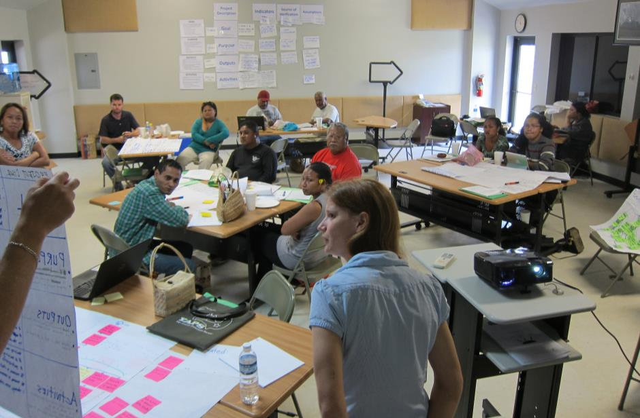

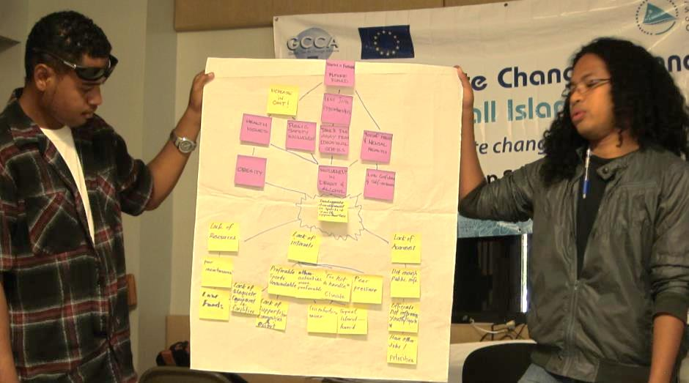

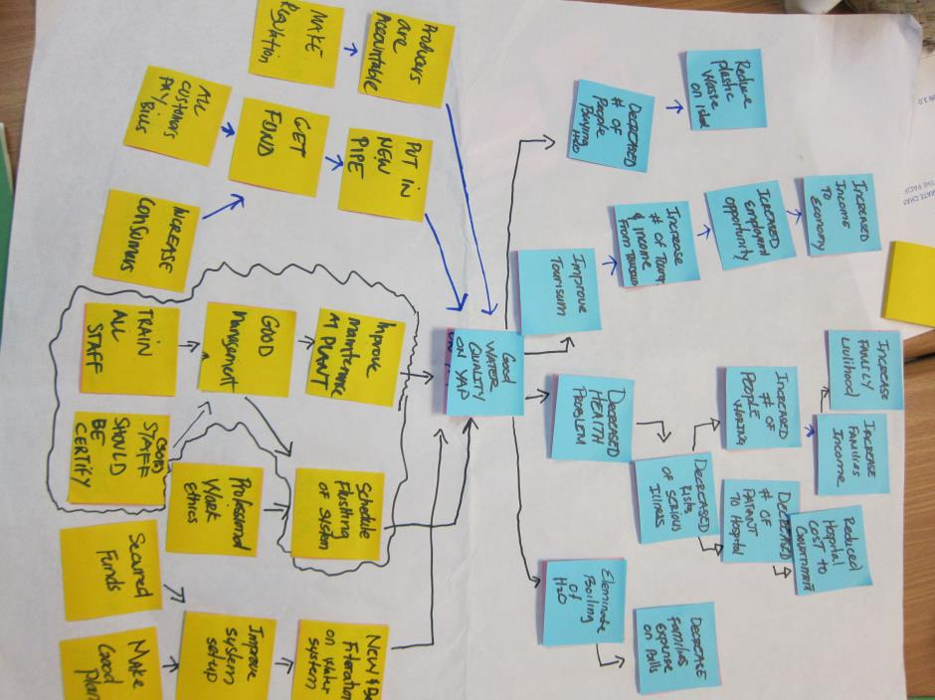

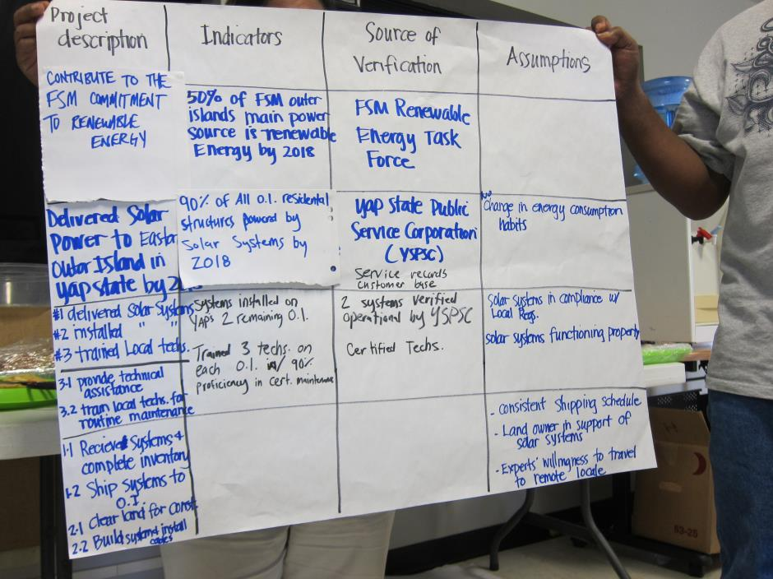

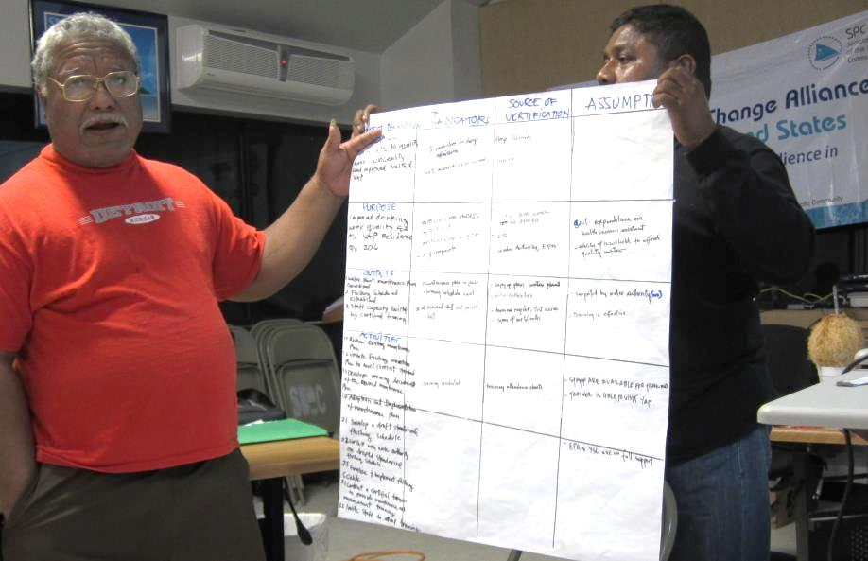

**Annex 4**

# POST TRAINING EVALUATION FORM – Yap

**Completed by 25 participants**

|  |  |  |  |  |  |  |  |  |
| --- | --- | --- | --- | --- | --- | --- | --- | --- |
| The training was well structured | 9 | 5 | 2 | 🞎 | 🞎 | 🞎 | 🞎 | The training was poorly structured |

|  |  |  |  |  |  |  |  |  |
| --- | --- | --- | --- | --- | --- | --- | --- | --- |
| The activities gave me the confidence that I can apply the knowledge in my work | 7 | 9 | 🞎 | 🞎 | 🞎 | 🞎 | 🞎 | The activities did not give me confidence that I can apply the knowledge in my work |

|  |  |  |  |  |  |  |  |  |
| --- | --- | --- | --- | --- | --- | --- | --- | --- |
| I found the learner guide useful | 13 | 3 | 🞎 | 🞎 | 🞎 | 🞎 | 🞎 | I did not find the learner guide useful |

|  |  |  |  |  |  |  |  |  |
| --- | --- | --- | --- | --- | --- | --- | --- | --- |
| I learnt things that will be useful to my work | 13 | 2 | 1 | 🞎 | 🞎 | 🞎 | 🞎 | I did not learn things that will be useful to my work |

|  |  |  |  |  |  |  |  |  |
| --- | --- | --- | --- | --- | --- | --- | --- | --- |
| The course was well presented | 10 | 3 | 2 | 1 | 🞎 | 🞎 | 🞎 | The course was poorly presented |

|  |  |  |  |  |  |  |  |  |
| --- | --- | --- | --- | --- | --- | --- | --- | --- |
| The facilitators made the material enjoyable | 10 | 4 | 1 | 1 | 🞎 | 🞎 | 🞎 | The facilitators did not make the material enjoyable |

For each of the following, please rate your level of confidence in being able to undertake the following steps of the logical framework approach when you get back to your job.

|  |  |  |  |  |  |  |  |  |
| --- | --- | --- | --- | --- | --- | --- | --- | --- |
| *Very confident* |  |  |  |  |  |  |  | *Not at all confident* |
| Stakeholder analysis | 5 | 9 | 1 | 1 | 🞎 | 🞎 | 🞎 |  |
| Problem analysis | 4 | 11 | 1 | 🞎 | 🞎 | 🞎 | 🞎 |  |
| Solution analysis | 6 | 8 | 1 | 1 | 🞎 | 🞎 | 🞎 |  |
| Logframe matrix | 3 | 9 | 3 | 1 | 🞎 | 🞎 | 🞎 |  |

|  |  |  |  |  |  |  |  |  |
| --- | --- | --- | --- | --- | --- | --- | --- | --- |
| I am confident that I can put together a good project proposal | 4 | 3 | 5 | 2 | 1 | 1 | 🞎 | I am not confident that I can put together a good project proposal |

|  |  |  |  |  |  |  |  |  |
| --- | --- | --- | --- | --- | --- | --- | --- | --- |
| I would recommend this course to my colleagues | 11 | 3 | 1 | 🞎 | 1 | 🞎 | 🞎 | I would not recommend this course to my colleagues |

|  |  |  |
| --- | --- | --- |
| Four days for the course was: | About right | 8 |
|  | Too short | 8 |
|  | Too long | 0 |

What was the most useful thing you learnt on this course?

Donors information

LFM and LFA format and method

A better way to write a proposal

Everything about the LFA

LFA

LFA method itself

LFA- how to structure a grant proposal

The analysis

LFM and LFA format and method

The most useful thing that I think I learnt from this course is problem analysis and how to do a good proposal

How to utilise a problem tree in the logframe and about different donors

The LFA

Everything is very useful to my work which I have learnt from this training. Especially the steps of the LFA & LFM

Logframe matrix, problem tree, solution tree; help me to write my proposal and I will asks Rachael to help me

The LFA 4 analysis thing: 1. Stakeholders, 2. Problem tree, 3. Solution, 4. Strategy

The logical order of doing things as presented in the course makes things easier to put a whole package together. The result of the analysis really outlines the whole thing out and it will be just a matter of connecting all of it together

The course would have been more effective if:

Schedule follows the break out sessions

Participants involved and not just fed

It was longer (time period)

More time to review, test it out - but not necessary

There were more examples and figures

One more day

If it was taught longer than just a week

The course would have been more effective of there is a second part of it.

The course was OK and help me to learn more about the proposal

If more proposal writing exercises done by participants

If the participants were notified ahead of time to come in with actual projects to work on. Also the size of the group, it would have been better to concentrate on two or three projects and work on them to a point where they are ready to be written up

Which topic(s), if any, do you want follow-up training on?

LFM x 3

Update on format

Logframe matrix seems to be the most crucial step and would be helpful to solidify the material again

LFM- specifically assumptions, and M&E

M&E

I am still confused on the LFM, so I still would love to follow up on this training sometime.

Evaluation, especially how it can relate to grant/project management

Writing proposals, presenting to donors the right material

Put together the proposal

About the water uality to the people at the outer island. If it is possible when the next training

LFM and budget

Solution analysis

Do you have any further comments or feedback about any aspects of the training?

This is adequate and need follow-up trainings in few months time

I enjoyed everything

Really useful

The training was useful to me. Thank you!! Hope you like the way we act or behave

I think I had a great time learning all about proposals.

Like the examples, more please

Great job guys! If only our government could pay people like you to give workshops like these every month… I say yes! To mentoring!!

More training like this

No comments, training was perfect. Thanks Martin and Damien

See if each state can point out some project for their state to ask for donor assistance, and use the proposal exercise during the LFA workshop training period.

Not really, just greatful to have the opportunity to attend and really want to thank the instructors for their effort and allowing the relaxed mood that allow great participantion and involvement from the training participants.