 

**GLOBAL CLIMATE CHANGE ALLIANCE:**

**PACIFIC SMALL ISLAND STATES PROJECT**

**REPORT ON POHNPEI CAPACITY DEVELOPMENT IN PROPOSAL PREPARATION USING THE LOGICAL FRAMEWORK APPROACH WORKSHOP**

**3-7 February 2014**

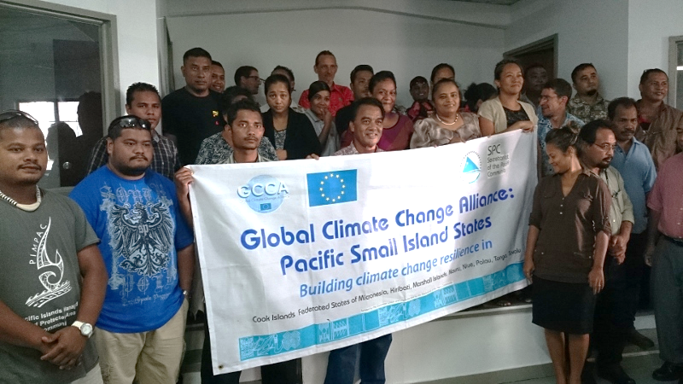

**Introduction**

The Global Climate Change Alliance: Pacific Small Island States (GCCA: PSIS) project is funded by the European Union (EU) and implemented by the Secretariat of the Pacific Community (SPC) in collaboration with the Secretariat of the Pacific Regional Environment Organisation (SPREP). The project budget is €11.4 million. The implementation period for the GCCA: PSIS project is from the date of signature of the agreement, 19 July 2011, to 19 November 2014.

The overall objective of the EU funded GCCA: PSIS project is to support the governments of nine Pacific smaller island states, namely Cook Islands, Federated States of Micronesia (FSM), Nauru, Marshall Islands, Nauru, Nauru, Palau, Tonga and Nauru, in their efforts to tackle the adverse effects of climate change. The purpose of the project is to promote long term strategies and approaches to adaptation planning and pave the way for more effective and coordinated aid delivery on climate change at the national and regional level.

The project approach is to assist the nine countries design and implement practical on-the-ground climate change adaptation projects in conjunction with mainstreaming climate change into line ministries and national development plans; thereby helping countries move from an *ad hoc* project-by-project approach towards a programmatic approach underpinning an entire sector. This has the added advantage of helping countries better position themselves to access and benefit from new sources and modalities of climate change funding, e.g. national and sector budget support.

**GCCA: PSIS Capacity development in proposal preparation using the logical framework approach Project (‘LFA training’) in Pohnpei, Federated States of Micronesia**

Following a regional workshop on Climate Finance and Proposal Preparation held in Apia, Samoa, 26 – 27 October 2012, and supported by the Asia-Pacific Adaptation Network (APAN), Secretariat of the Pacific Regional Environment Program (SPREP) and SPC, six of the countries (Cook Islands, Federated States of Micronesia, Marshall Islands, Nauru, Nauru and Nauru) involved in the GCCA: PSIS project expressed their interest in having a national training workshop on project proposal preparation using the logical framework approach. FSM made a special request to conduct a training in each of their four states. This LFA training project responds to that expressed need. The project provides a valuable opportunity to strengthen national government staff to develop successful and integrated climate change adaptation project proposals. This will allow PSIS and donors to work together to ensure a more effective and coordinated aid delivery to address climate change at the national and regional level.

The Pohnpei (FSM) training workshop was delivered over 4 days (3-6 February 2014), with an additional morning of mentoring on 7 February 2014. Pacific Research and Evaluation Associates (PREA) were contracted to deliver the LFA training, based on the resources that they had previously developed and piloted in the Cooks Islands. The workshop was held in the Western and Central Pacific Fisheries Commission conference room and was attended by thirty-three participants.

The training made use of a donor directory (Donors for Climate Change Adaptation in the Pacific) developed for SPC and SPREP. PREA also researched additional donors active in the Pacific region who support PSIS. All relevant training resources were provided to participants in hardcopy with an electronic copy provided on a USB stick for all participants.

The training needs analysis was sent electronically to participants prior to the workshop. Twenty-three participants completed the training but only a few had any real experience with proposal writing or any components of the LFA.

The key topics covered during the LFA training include a background on the project management cycle, a detailed look of the logical framework approach, proposal writing (informed by the LFA) and a brief summary of climate change donors active in the Pacific region. A detailed delivery plan is included in Annex 1.

The LFA training workshop was organised by SPC with support from in-country staff Ms Victorina Loyola-Joab from the SPC, and Ms Cynthia Ehmes, Assistant Director, Environment Conservation Division, Office of Environment and Emergency Management. Assistance was also provided by Belinda Hadley, FSM OEEM SPC Climate Change Coordinator.

Mr Andrew Yatilman, Director OEEM, of the FSM Government, welcomed participants and officially opened the workshop. Ms Pasha Carruthers, Climate Change Adviser – North Pacific (SPC GCCA: PSIS) also provided opening remarks, providing context for the training workshop, and background to the SPC GCCA: PSIS project in the FSM.

After introductions, the two training facilitators from PREA began workshop proceedings for day 1.

**Workshop Participants**

Thirty-three participants attended the training over the four day workshop program representing various departments of the FSM and Pohnpei State Governments and some NGOs (see Annex 2). The training was well attended over the four days, and represented the largest workshop held to date. Learner guides, slide packs and USB flash drives were distributed to all participants.

**Workshop Results**

Training delivery included a mix of informative presentations, large group activities to demonstrate new knowledge and skills followed by small group activities where participants were challenged to use the knowledge and skills for real-life project ideas they wanted to develop (see Annex 3 for photo of group work). There were three small project groups that worked through the LFA, representing the following project ideas:

1. Community water catchment for climate change resilience in rural and outer islands of Pohnpei
2. Improving internet access for youth and elderly people in rural communities of Pohnpei
3. Promoting FSM culture in the Pacific through attendance at the 2016 Pacific Arts Festival in Guam
4. Reducing energy consumption at the Pohnpei hospital
5. Improving food security in Pohnpei households through promotion of food gardens and local food consumption
6. Increasing access to local produce in Pohnpei urban centres through assistance to farmers and market stall holders

The whole-of-class activity focussed on reducing the level of littered trash in Pohnpei. This topic was used instead of the case study in the learner guide.

The facilitators moved between groups to offer support and advice where required. The presence of two facilitators was valued by participants for both the presentations and the detailed group work. Start of day and post-lunch warm-up activities were conducted to refresh participants and prepare them for learning. Each day began with a recap of the preceding day and each day ended with a re-cap of the days’ content.

The in-country staff organised a panel of three donor guest presenters, Liz Terk from The Nature Conservancy (TNC), Okean Ehmes, from UN Joint Presence Office, and Fenno Brunken from the GIZ/SPC Coping with Climate Change in the Pacific Islands Region programme..

The workshop concluded on day group performances which reflected what participants had learnt, group photo and certificate of attendance presentation conducted by Cynthia Ehmes for FSM OEEM and Pasha Carruthers of SPC.

**Workshop Evaluation**

The results of the workshop evaluation are presented as Annex 4. Twenty-four participants who attended the four days completed the evaluation form.

The Pohnpei training was very successful, due to the large number of participants, and with participants indicating that they valued the learning opportunity the course presented. Participants worked well in their project groups and generally actively engaged in group activities. However, some participants noted in the post-workshop questionnaire that it would have been better if some participants were more active during group work.

The training generally commenced late on the first day due to the Superbowl. As such, the first day only allowed three hours of workshop. The facilitators reduced the length of some activities and did not present on monitoring and evaluation in order to catch up by the final day. This was achieved, but 10 of 13 respondents indicated the course could have been longer, and several commented that more time could have been given to activities.

Most participants indicated a strong to fair degree of confidence in being able to complete the stakeholder analysis, problem tree and solution tree steps of the logical framework approach upon their return to work. There was also strong confidence in developing a logframe matrix and putting it all together to develop a proposal. Participant comments indicated a strong appreciation for the systematic and participatory process provided by the logical framework approach.

***What participants found most useful***

*The LFA, problem tree and solution tree. Most useful was the learning of the concepts from the different group presentations on various areas of interest.*

*The overall presentation of log frame matrix is very useful*

*Importance of speaking with all stakeholders from the beginning - before having a project in mind*

*The logical framework problem analysis*

When asked about follow up training, participants’ comments included a range of responses:

1. Logframe matrix
2. All of the LFA
3. More on proposal writing

All of the participants indicated that they would recommend the course to their colleagues. There were nearly equal numbers of participants who indicated the course was the right length, and those who wanted it to be longer.

The participants all indicated satisfaction with the delivery, and the resources provided. The following comments reflect the success of the Pohnpei training delivery.

*Training was exciting as it involved many group activities and fun activities.*

*The flash drive as a source of storing information is very good since we can always refresh our memories with the important information stored in it.*

*The training was very constructive and informative*

*Overall very well done. Highlights: 1. two different speakers presenting at one given time, 2. Lots of practical exercises. 3. Lots of group activities, 4. Definitely keeps me awake, 5. Very critical information to my work*

*I hope this kind of workshop conducted next year*

*Very well conducted*

*Well organised and put together*

*Very well delivered*

The medium term outcomes resulting from the training will be assessed through issuing a longitudinal post-training survey (3 – 6 months after the training) combined with telephone interviews.

**Conclusion**

The training was very successful in building capacity and motivation of FSM and Pohnpei government staff and NGO members to use the logical framework approach to design projects and inform the preparation of proposals. The participants noted the benefits of thinking through projects at the design stage, rather than jumping straight to solutions or actions. The impact evaluation in several months’ time will determine whether any of the projects worked on during the training will be developed up into real proposals. A number of participants indicated their intention to develop their group project into proposals. There was also a strong interest in developing their skills further by working together to practice the steps of the LFA. The training has also provided some participants with the skills to approach problems with more confidence, and use this to find solutions in in collaboration with all stakeholders.

**Annex 1 Workshop Agenda**

**Secretariat of the Pacific Community**

**Pohnpei**

**Global Climate Change Alliance: Pacific Small Island States**

**PROPOSAL PREPARATION USING THE LOGICAL FRAMEWORK APPROACH WORKSHOP**

*Delivery plan summary*

|  |  |
| --- | --- |
|  | Task / Topic |
| Day 1 | Welcome  Gathering group knowledge  Introduction to the LFA  Project Management Cycle  Step 1. Stakeholder Analysis  Step 2. Problem analysis |
| Day 2 | Step 2. Problem analysis continued  Step 3. Solution Analysis  Step 4. Strategy Analysis – Selecting solutions  Step 5. Logframe Matrix |
| Day 3 | Step 5: Logframe Matrix continued  Step 6: Activity Scheduling |
| Day 4 | Step 7: Resource Scheduling  Proposal Writing  Donor agencies  Celebration and group performances  Final feedback and evaluation |

**Annex 2 Participants List**

|  |  |  |  |  |  |
| --- | --- | --- | --- | --- | --- |
|  |  |  |  |  | **Gender** |
| **Name** | **Position/Job Title** | **Organisation** | **Email** | **Telephone** | **M / F** |
| Abello, Mario | Early Childhood Education Specialist | Dept. of Education | [mabello@fsmed.fm](mailto:mabello@fsmed.fm) | (691)320-2609 | M |
| Aldis, Bermance | Program Manger | Dept. of R&D | [baldis@fsmrd.fm](mailto:baldis@fsmrd.fm) | (691)320-5133 | M |
| Anson, Jorg | Program Manger | NGO - Conservation Society of Pohnpei | [cspmarine@serehd.org](mailto:cspmarine@serehd.org) | (691)320-5409 | M |
| Priana Andreas | Public Information Officer | Social Security Administration | [sspio@mail.fm](mailto:sspio@mail.fm) | (691)320-2706 | M |
| Eldridge, Jimmy | Education Specialist | Pohnpei State Government | [luelen04@yahoo.com](mailto:luelen04@yahoo.com) | (691)320-2103 | M |
| Enicar, Arisako |  | Dept. of R&D | [aenicar@fsmrd.fm](mailto:aenicar@fsmrd.fm) | (691)320-5133 | F |
| Falcam, Andrew | Education Coordinator | Conservation Society of Pohnpei | [educoordinator@serehd.org](mailto:educoordinator@serehd.org) |  | M |
| Ilai, Fransky | Claims Manager | Social Security Administration | **same as above** | (691)320-2706 | M |
| Gonzaga, Shinmaysin | National Food Inspector | Dept. of Health | [sgonzaga@fsmhealth.fm](mailto:sgonzaga@fsmhealth.fm) | (691)320-2619 | F |
| Hadley, Belinda | SPC FSM National Coordinator | OEEM, Environment Unit | [belinhadley@gmail.com](mailto:belinhadley@gmail.com) | (691)320-8814 | M |
| Hadley, Johnny Jr. | External Assistance Coordinator/Grant Writer | Pohnpei State Government | [dipwinmen@yahoo.ocm](mailto:dipwinmen@yahoo.ocm) | (691)320-7678 | M |
| Jonathan, Angel | Environmental Educator | Conservation Society of Pohnpei | [angeljonathan@gmail.com](mailto:angeljonathan@gmail.com) |  | M |
| Joseph, Adelman |  | Dept. of R&D | [adelman.joseph@fsmrd.fm](mailto:adelman.joseph@fsmrd.fm) | (691)320-5133 | M |
| Joseph, Person | Youth Program Coordinator, Social Affairs Office | Pohnpei State Government | [personjoseph15@yahoo.com](mailto:personjoseph15@yahoo.com) | (691)320-5142 | F |
| Kusto, Carlos | Grants Officer | NGO - Micronesia Conservation Trust | [grants@ourmicronesia.org](mailto:grants@ourmicronesia.org) | (691)320-5670 | M |
| Lemuel, Roster | Federal Program Coordinator, Historic Preservation Office | Pohnpei Sate Government | [rosterlemuel@yahoo.com](mailto:rosterlemuel@yahoo.com) | (691)3202652 | F |
| Ligohr, Shirley | Aid Coordinator/Budget Office | Pohnpei State Government | [sligohr@yahoo.com](mailto:sligohr@yahoo.com) |  | F |
| Lorens, Adelino | Administrator, Economic Affairs | Pohnpei State Government | [catalinolorens@yahoo.com](mailto:catalinolorens@yahoo.com) | (691)320-2712 | M |
| Marguez, Roseo | Senior Grants Officer | NGO - Micronesia Conservation Trust | [sgo@ourmicronesia.org](mailto:sgo@ourmicronesia.org) | (691)320-5670 | M |
| Mathias, Dave |  | Dept. of R&D | [dave.mathias@fsmrd.fm](mailto:dave.mathias@fsmrd.fm) | (691)320-5133 | M |
| Pernet, Tony | Chief, Divison of Fish & Wildlife | Pohnpei State Government | [publicsafety@mail.fm](mailto:publicsafety@mail.fm) | (691)320-8151 | M |
| Peter, Anderson | Customs Specialist | CTA Central Office | [andersonptr@yahoo.com](mailto:andersonptr@yahoo.com) | (691)320-5855 | M |
| Petrus, Patty | Sustainable Development Planner | OEEM, Environment Unit | [pattiwarm@gmail.com](mailto:pattiwarm@gmail.com) | (691)320-8814 | M |
| Saimon, Joseph | Administrator, Office of Fisheries & Acquaculture | Pohnpei Sate Government | [josedin@gmail.com](mailto:josedin@gmail.com) | (691)320-2298 |  |
| Santos, Edgar | Administrator, Pohnpei Hospital | Pohnpei Sate Government | [fredka7101@yahoo.com](mailto:fredka7101@yahoo.com) |  | M |
| Semens, Alan |  | SBOC | [asemens@sboc.fm](mailto:asemens@sboc.fm) | (691)320-2823 | M |
| Sigrah-Asher, Shanty | Assistant Depty Secretary | Dept. of Foreign Affairs | [shantysigrah@gmail.com](mailto:shantysigrah@gmail.com) | (691)320-2641 | F |
| Simon, Josephine | Medical Director, Community Health Center | Pohnpei State Government | [jmsaimons@yahoo.com](mailto:jmsaimons@yahoo.com) | (691)320-2438 | M |
| Susaia, Henry | Environmental Specialist II | Pohnpei State Government | [hsusaia@gmail.com](mailto:hsusaia@gmail.com) | (691)320-1780 | M |
| Tara, Mona | Office Manager | NGO - Island Food Community | same as above | (691)320-3259 | M |
| Turner, April | Food Security Project Officer | NGO - Island Food Community | [communitydevelopment@islandfood.org](mailto:communitydevelopment@islandfood.org) | (691)320-3259 | M |
| Williander, Willie |  | Dept. of R&D | [wwilliander@fsmrd.fm](mailto:wwilliander@fsmrd.fm) | (691)320-5133 | F |
| Yatilman, FJ |  | Dept. of R&D | [fjyatilman@yahoo.com](mailto:fjyatilman@yahoo.com) | (691)320-5133 | **M** |

**Annex 3**

**Photos of workshop activities**

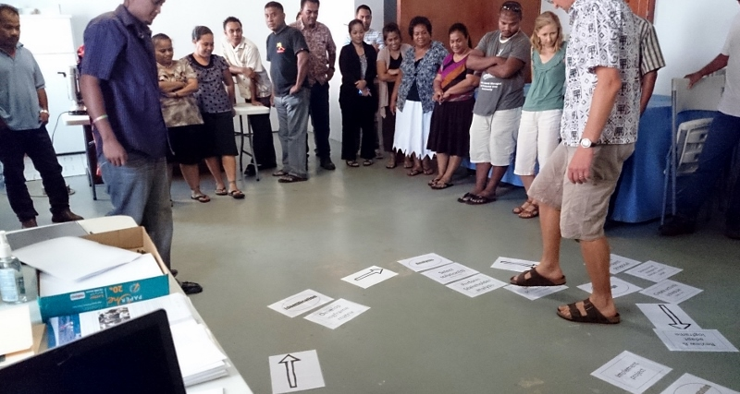

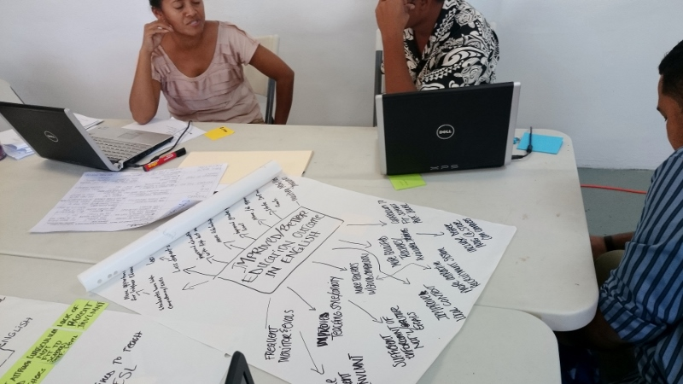

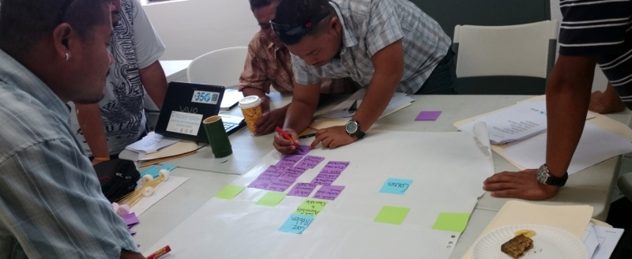

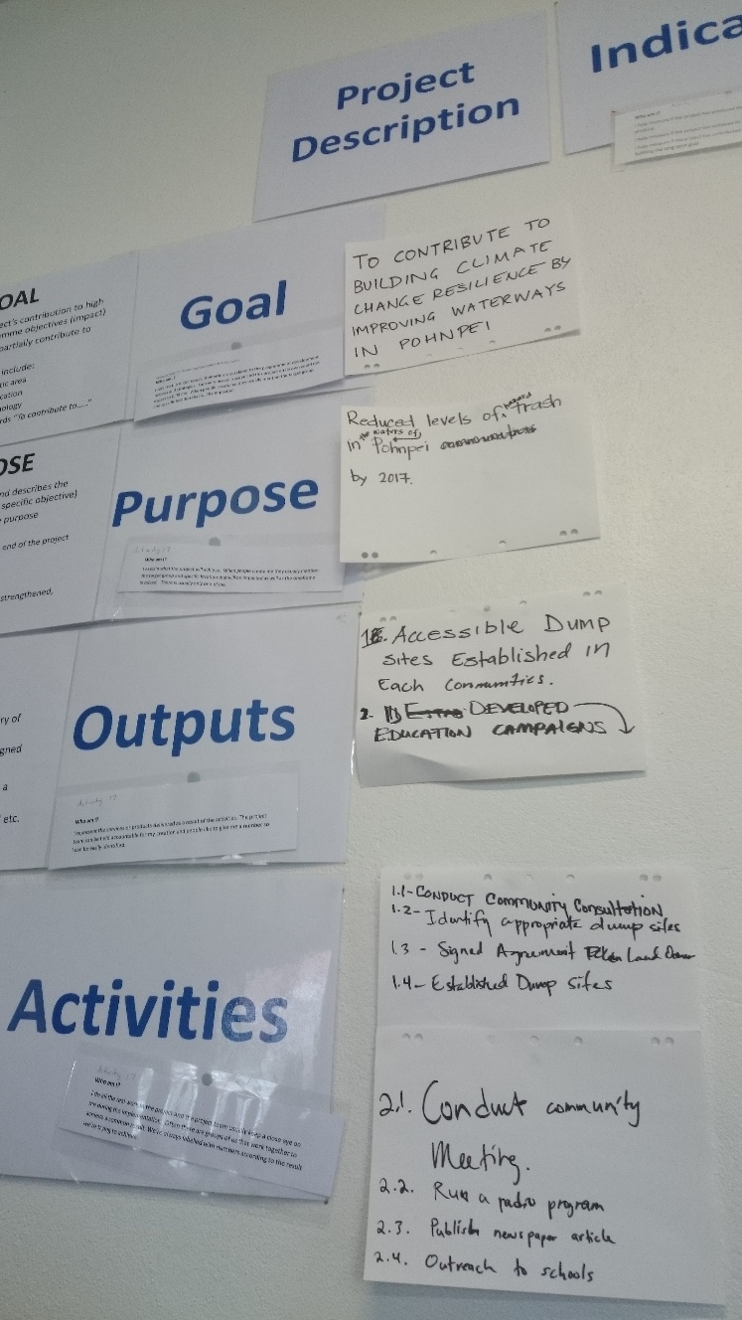

**Annex 4**

# POST TRAINING EVALUATION FORM – POHNPEI

**Completed by 24 participants**

|  |  |  |  |  |  |  |  |  |
| --- | --- | --- | --- | --- | --- | --- | --- | --- |
| The training was well structured | 17 | 7 | 🞎 | 🞎 | 🞎 | 🞎 | 🞎 | The training was poorly structured |

|  |  |  |  |  |  |  |  |  |
| --- | --- | --- | --- | --- | --- | --- | --- | --- |
| The activities gave me the confidence that I can apply the knowledge in my work | 20 | 4 | 🞎 | 🞎 | 🞎 | 🞎 | 🞎 | The activities did not give me confidence that I can apply the knowledge in my work |

|  |  |  |  |  |  |  |  |  |
| --- | --- | --- | --- | --- | --- | --- | --- | --- |
| I found the learner guide useful | 21 | 2 | 1 | 🞎 | 🞎 | 🞎 | 🞎 | I did not find the learner guide useful |

|  |  |  |  |  |  |  |  |  |
| --- | --- | --- | --- | --- | --- | --- | --- | --- |
| I learnt things that will be useful to my work | 15 | 7 | 🞎 | 1 | 🞎 | 🞎 | 🞎 | I did not learn things that will be useful to my work |

|  |  |  |  |  |  |  |  |  |
| --- | --- | --- | --- | --- | --- | --- | --- | --- |
| The course was well presented | 19 | 4 | 1 | 🞎 | 🞎 | 🞎 | 🞎 | The course was poorly presented |

|  |  |  |  |  |  |  |  |  |
| --- | --- | --- | --- | --- | --- | --- | --- | --- |
| The facilitators made the material enjoyable | 18 | 4 | 2 | 🞎 | 🞎 | 🞎 | 🞎 | The facilitators did not make the material enjoyable |

For each of the following, please rate your level of confidence in being able to undertake the following steps of the logical framework approach when you get back to your job.

|  |  |  |  |  |  |  |  |  |
| --- | --- | --- | --- | --- | --- | --- | --- | --- |
| *Very confident* |  |  |  |  |  |  |  | *Not at all confident* |
| Stakeholder analysis | 11 | 8 | 3 | 🞎 | 🞎 | 🞎 | 🞎 |  |
| Problem analysis | 10 | 10 | 2 | 🞎 | 🞎 | 🞎 | 🞎 |  |
| Solution analysis | 11 | 9 | 2 | 🞎 | 🞎 | 🞎 | 🞎 |  |
| Logframe matrix | 12 | 5 | 4 | 🞎 | 🞎 | 🞎 | 🞎 |  |

|  |  |  |  |  |  |  |  |  |
| --- | --- | --- | --- | --- | --- | --- | --- | --- |
| I am confident that I can put together a good project proposal | 10 | 11 | 2 | 🞎 | 🞎 | 🞎 | 🞎 | I am not confident that I can put together a good project proposal |

|  |  |  |  |  |  |  |  |  |
| --- | --- | --- | --- | --- | --- | --- | --- | --- |
| I would recommend this course to my colleagues | 22 | 2 | 🞎 | 🞎 | 🞎 | 🞎 | 🞎 | I would not recommend this course to my colleagues |

|  |  |  |
| --- | --- | --- |
| Four days for the course was: | About right | 13 |
|  | Too short | 10 |
|  | Too long | 🞎 |

What was the most useful thing you learnt on this course?

All contents

Creating a problem tree that was the most useful as it makes all the following steps easier. When converted to a solution tree it makes it more understandable.

The LFA, problem tree and solution tree. Most useful was the learning of the concepts from the different group presentations on various areas of interest. The directory of donors is vital.

LFA, proposal writing

The use of the logframe matrix to plan proposals

LFA (bascially the whole concept of LFA)

Steps in the LFA, LFM, Donors, Roughly everything

Networking

The overall presentation of log frame matrix is very useful

All the courses I learn from it

How to put together a proposal, but need more feedback

Importance of speaking with all stakeholders from the beginning - before having a project in mind

The most useful thing I learnt from this course is the variety of information on donors and methodologies of writing proposals

Importance of identifying stakeholders, can be simplified and help me focus on my project priorities and what I want out of the project, developing partners, networking, and building a relationship with donors are important

Developing the problem tree and converting to solution

The proposal writing

Preparing to come up with the proposal

Compiling problem tree and pulling info from it

To write a proposal

The logical framework problem analysis

The problem tree, solution tree and other things

Problem and solution tree

The most useful thing I learnt was the logframe matrix

Logframe matrix

The course would have been more effective if:

7 days long, 5 days learning, 2 days good written real project proposal, draft and final

If it covers one whole week (5 days) but all in all it is an enjoyable learning experience.

I would welcome more sharing of successful proposals, resources, templates.

More practical exercises being done

More background information is presented

There were more exercises

My other support staff attended

I do learn lots from it. Learn sequence of the matrix

I have few more days on the training

Participants were more active (nothing to do with presenters)

More time was give- 5 days perhaps, 4 full days, one half day

If times is extended

More time allocation to each stage

More days

If more time given to produce more proposals, more practice the better

There was more time

Right partners working together

More samples provided

We spent more time on writing proposals

Everything went well

Which topic(s), if any, do you want follow-up training on?

LFA- training again to improve

I would like to do a LFM follow up training as it is the key point for this workshop. Identifying indicators and assumptions are a bit confusing.

More LFA with solution analysis. Explore the technical details of contextualisation and customising proposals.

Using the matrix and putting together in actual proposal writing

Proposal writing, project management

Budget preparation

Collaboration, networking and speakers from local donors and agencies

The logframe

Historic Preservation and culture

Developing indicators that are easily measurable

logframe matrix

None- just dreaming to try one real one

All topics

All topics

logframe analysis

logframe matrix

Donor agencies formats (proposals)

Logframe matrix and proposal writing

Do you have any further comments or feedback about any aspects of the training?

Training was exciting as it involved many group activities and fun activities. I think you should give out more lollies.

The flash drive as a source of storing information is very good since we can always refresh our memories with the important information stored in it. I recommend that this 'give away' is helpful to review beyond the training.

1. To invite the person that would actually do the proposal. 2. Attendance to be mandatory. 3. Refreshments to be served during tea/coffee breaks only. 3. Guest speakers to speak in the invitation purpose.

The training was very constructive and informative

Overall very well done. Highlights: 1. two different speakers presenting at one given time, 2. Lots of practical exercises. 3. Lots of group activities, 4. Definitely keeps me awake, 5. Very critical information to my work

I hope this kind of workshop conducted next year

Keep me more open-minded of how to look for more grant or access to budget

Maybe not all groups needed to present after the group activity, every time- especially close to breaks or finish time. Use reusable cups/forks/plates (ask participants to bring their own or wash up) Very important for climate change groups- need to be role models.

Bravo! Thankyou :)

Discuss how the LFA is compared to other popular methods of proposal writing

Was all resourceful. As a new proposal writing student I have learned a lot

No comment, almost every given topic is well covered, except the time allocation is somewhat too short

Very well conducted

Well organised and put together

Very well delivered

All environmental agencies to attend

Very helpful workshop. It will be good of more stakeholders attended

Maybe more hands on activities would help out a lot more