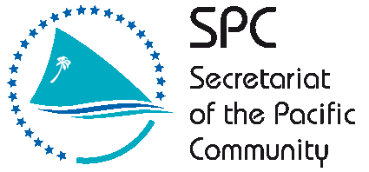

**SECRETARIAT OF THE PACIFIC COMMUNITY**

**GLOBAL CLIMATE CHANGE ALLIANCE:**

**PACIFIC SMALL ISLAND STATES PROJECT**

**FUNDED BY THE EUROPEAN UNION**

**REPORT ON KOSRAE CAPACITY DEVELOPMENT IN PROPOSAL PREPARATION USING THE LOGICAL FRAMEWORK APPROACH WORKSHOP**

**28 April – 1 May 2014**

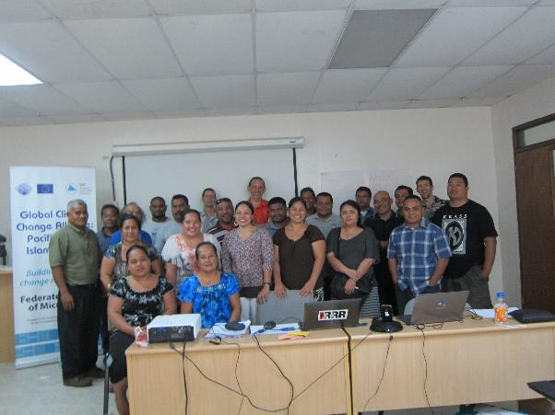

**Introduction**

The Global Climate Change Alliance: Pacific Small Island States (GCCA: PSIS) project is funded by the European Union (EU) and implemented by the Secretariat of the Pacific Community (SPC) in collaboration with the Secretariat of the Pacific Regional Environment Programme (SPREP). The project budget is €11.4 million. The implementation period for the GCCA: PSIS project is from the date of signature of the agreement, 19 July 2011, to 19 November 2014.

The overall objective of the EU funded GCCA: PSIS project is to support the governments of nine Pacific smaller island states, namely Cook Islands, Federated States of Micronesia (FSM), Nauru, Marshall Islands, Niue, Kiribati, Palau, Tonga and Tuvalu, in their efforts to tackle the adverse effects of climate change. The purpose of the project is to promote long term strategies and approaches to adaptation planning and pave the way for more effective and coordinated aid delivery on climate change at the national and regional level.

The project approach is to assist the nine countries design and implement practical on-the-ground climate change adaptation projects in conjunction with mainstreaming climate change into line ministries and national development plans; thereby helping countries move from an *ad hoc* project-by-project approach towards a programmatic approach underpinning an entire sector. This has the added advantage of helping countries better position themselves to access and benefit from new sources and modalities of climate change funding, e.g. national and sector budget support.

**GCCA: PSIS Capacity development in proposal preparation using the logical framework approach Project (‘LFA training’) in Kosrae**

Following a regional workshop on Climate Finance and Proposal Preparation held in Apia, Samoa, 26 – 27 October 2012, and supported by the Asia-Pacific Adaptation Network (APAN), Secretariat of the Pacific Regional Environment Program (SPREP) and SPC, all of the countries involved in the GCCA: PSIS project expressed their interest in having a national training workshop on project proposal preparation using the logical framework approach. FSM made a request to the GCCA: PSIS project to hold separate trainings in Yap, Kosrae and Chuuk in addition to the national training held in Pohnpei in February 2014. This particular training in Kosrae responds to that expressed need.

The Coping with Climate Change in the Pacific Island Region program (CCCPIR) implemented in partnership with Deutsche Gesellschaftfür Internationale Zusammenarbeit (GIZ) on behalf of the German Federal Ministry for Economic Cooperation and Development (BMZ) has assisted with the provision of logistical support for the training in Kosrae.

The training provides a valuable opportunity to strengthen national government staff to develop successful and integrated climate change adaptation project proposals. This will allow PSIS and donors to work together to ensure a more effective and coordinated aid delivery to address climate change at the national and regional level.

The Kosrae training workshop was delivered over 4 days (28 April – 1 May 2014). Pacific Research and Evaluation Associates (PREA) were contracted to deliver the LFA training, based on the resources that they had previously developed and piloted in the Cooks Islands. The workshop was held at the Kosrae Government Building and was attended by 25 participants.

The training made use of a donor directory (Donors for Climate Change Adaptation in the Pacific) developed for SPC and SPREP. PREA also researched additional donors active in the Pacific region who support PSIS. All relevant training resources were provided to participants in hardcopy with an electronic copy provided on a USB stick for all participants. Additional outputs (problem tree, solution tree and logframe matrix) created during the workshop were also included on the USB stick.

The key topics covered during the LFA training include a background on the project management cycle, a detailed look of the logical framework approach, proposal writing (informed by the LFA) and a brief summary of climate change donors active in the Pacific region. A detailed delivery plan is included in Annex 1.

The LFA training workshop was organised by SPC through Ms Victorina Loyola-Joab(SPC GCCA: PSIS) with support from the Federated States of Micronesia national government through Ms Belinda Hadley (SPC FSM National Coordinator, OEEM) and Blair Charley (Director, Kosrae Island Resource Management Authority). The Kosrae State Governor, Mr Jackson, welcomed participants and officially opened the workshop. Ms Victorina Loyola-Joab also provided opening remarks, providing context for the training workshop, and background to the SPC GCCA: PSIS project in Kosrae.

After introductions, PREA began workshop proceedings for day 1. The training generally commenced 8:30am and finished at 3pm on each training day as this was the usual work hours in Kosrae. This facilitators adjusted the delivery plan to match the delivery hours. This meant that several energizer activities, and the end of workshop performances were cut from the training. There was also no time to present on monitoring and evaluation.

**Workshop Participants**

Twenty-five participants actively participated in the training over the four day workshop program representing various departments of the Kosrae State Government and some NGOs (see Annex 2). The training was well attended over the four days. Learner guides and slide packs and USB flash drives were distributed to all participants.

**Workshop Results**

Training delivery included a mix of informative presentations, large group activities to demonstrate new knowledge and skills followed by small group activities where participants were challenged to use the knowledge and skills for real-life project ideas they wanted to develop (see Annex 3 for photo of group work). There were four small project groups that worked through the LFA, representing the following project ideas:

1. Coastal erosion
2. Improving fish stocks for the coastal fishery
3. Improving inorganic waste management/collection
4. Improving staff skills at the day care

The whole-of-class activity focussed on reducing polystyrene cup pollution on land and in waterways.

The facilitators moved between groups to offer support and advice where required. The presence of two facilitators was valued by participants for both the presentations and the detailed group work.

Mr Fenno Brunken from GIZ, Pohnpei, made a presentation from a donor’s perspective on Day 3 of the training. This was followed by a question and answer session.

The workshop concluded on day four with a certificate of attendance presentation conducted by Ms Belinda Hadley, Ms Victorina Loyola-Joab and Mr Fenno Brucken.

**Workshop Evaluation**

The results of the workshop evaluation are presented as Annex 4. Post workshop questionnaires were not available so the evaluation consisted of two ‘dartboards[1]’ and comment forms. Participants were asked to rate different elements of the workshop on one dartboard, and their level of confidence in undertaking key steps of the LFA, and proposal writing on the other dartboard.

The Kosrae training was successful with 25 participants attending the workshop. This indicates that they valued the learning opportunity the course presented. Participants worked well in their project groups and each group completed all planned activities. There was a good amount of participation, discussion and critical feedback offered in response to project group presentations.

All participants reported that they learnt new useful knowledge and skills at the workshop. Participants indicated that the activities and learner guide were useful. Overall, participants found the course well presented, as indicated by the dartboard results and comments provided in Annex 4 (and excerpts from comments below).

***What participants found most useful***

*Develop proposals and budget for the proposals*

*Discussions on many topics covered*

*Logframe process and proposal development*

*Transforming outcomes from the problem/solution tree to the LFA matrix*

Nearly all participants reported having confidence to undertake the key steps of the LFA. Participant comments indicated that they wanted some more work around:

1. LFA training and exercises
2. Logframe matrix
3. Proposal writing
4. Monitoring and evaluation

Participants also indicated that they would recommend the training to their colleagues. This supports the finding that the participants found the course useful.

The following comments reflect the success of the Kosrae training delivery.

*Learning materials are well prepared, simple language, with consistent presentation reflecting the materials*

*Fully satisfied with the trainers and their teaching. Truly satisfied – bullseye!!*

*Everything presented at the training is very useful and appreciate very much to be part of it*

*The workshop was fun and very interesting due to multiple aspects of it. I really enjoyed the training and felt the need of having it on the island since the capacity of constructing a project proposal is not really well-developed or well-understood.*

*Very well liked from beginning to end (clearly presented and explained)*

The medium term outcomes resulting from the training will be assessed through issuing a longitudinal post-training survey (3 – 6 months after the training) combined with telephone interviews.

One recommendation arising from the Kosrae training is that the starting and end time for the training are clearly communicated to participants in advance so that participants are prepared to work beyond their scheduled work hours. In Kosrae, the work day ends at 3pm, and not all participants were willing to stay beyond this time. The facilitators were required to adjust the delivery to accommodate the work hours of the participants, but this necessitated cutting out some elements of the training, as well as shortening breaks.

**Conclusion**

The proposal writing training was successful in building capacity and motivation of Kosrae State government staff and NGO members to use the logical framework approach to design projects and inform the preparation of proposals. The participants noted the benefits of thinking through projects at the design stage rather than jumping straight to solutions or actions. Whilst participants acknowledged the additional time required to complete the LFA process, they also saw the benefit of how the process can inform a robust proposal. A number of the small project group logframes are likely to be developed into proposals which demonstrates the benefits of the training. The impact evaluation in several months’ time will determine if the projects worked on during the training were developed up into real proposals.

**Annex 1 Workshop Agenda**

**Secretariat of the Pacific Community**

**Kosrae**

**Global Climate Change Alliance: Pacific Small Island States**

**PROPOSAL PREPARATION USING THE LOGICAL FRAMEWORK APPROACH WORKSHOP**

*Delivery plan summary*

|  |  |
| --- | --- |
|  | Task / Topic |
| Day 1 | Welcome  Gathering group knowledge  Introduction to the LFA  Project Management Cycle  Step 1. Stakeholder Analysis  Step 2. Problem analysis |
| Day 2 | Step 2. Problem analysis continued  Step 3. Solution Analysis  Step 4. Strategy Analysis – Selecting solutions  Step 5. Logframe Matrix |
| Day 3 | Step 5: Logframe Matrix continued |
| Day 4 | Step 6: Activity Scheduling  Step 7: Resource Scheduling  Proposal Writing  Donor agencies  Certificate Presentation  Final feedback and evaluation |

**Annex 2 Participants List**

|  |  |  |  |  |
| --- | --- | --- | --- | --- |
| **Name** | **Position/Job Title** | **Organisation** | **Email** | **Telephone** |
| Alerson Alik | Program Coordinator | DOHS | [aaalik@fsmhealth.fm](mailto:aaalik@fsmhealth.fm) | 370-4405 |
| Beth Josey | Administative Assistant | DREA | [bth_osie@hotmail.com](mailto:bth_osie@hotmail.com) | 370-2044 |
| Betty Sigrah | Program Manager | Micronesia Conservation Trust | [capacity@ourmicronesia.org](mailto:capacity@ourmicronesia.org) | 370-5936 |
| Blair Charley | Director | KIRMA | [charleyblair@gmail.com](mailto:charleyblair@gmail.com) | 320-2076 |
| Bruce Kihleng | Administrative Officer | KIRMA | [b.e.kihleng@gmail.com](mailto:b.e.kihleng@gmail.com) | 320-2076 |
| Bruno Ned | Specialist | Div. of Fisheries Development | [fisherieskos@mail.fm](mailto:fisherieskos@mail.fm) | 370-3031 |
| DeBrum Melander | KIRMA Board member | KIRMA | [tafinite@yahoo.com](mailto:tafinite@yahoo.com) |  |
| Erick E. Waguk | Forester | KIRMA | [wakukarick@yahoo.com](mailto:wakukarick@yahoo.com) | 370-3078 |
| Lelean Kephas |  | Kosrae Construction | [kcso@mail.fm](mailto:kcso@mail.fm) | 370-3673 |
| Likiak Melander | Env. Education Coordinator | KIRMA | [likiakmelander@gmail.com](mailto:likiakmelander@gmail.com) | 370-2076 |
| Linson Waguk | President | Gateway Community Group | [wagukl@yahoo.com](mailto:wagukl@yahoo.com) | 370-3185 |
| Mary Livaie | President | Kosrae Women Association | [mlivaie@yahoo.com](mailto:mlivaie@yahoo.com) | 370-3002 |
| Maxwell H. Salik | Administator | Fisheries | [fisherieskos@mail.fm](mailto:fisherieskos@mail.fm) | 370-3031 |
| Nena William | Disaster Management Officer | Governor's Office | [kosraedco@gmail.com](mailto:kosraedco@gmail.com) | 370-3009 |
| Presley Abraham | Development Project Coordinator | KIRMA | [kjjpal@yahoo.com](mailto:kjjpal@yahoo.com) | 370-2076 |
| Priscilla Laborete | Budget Analyst | DOA | [plaborete@ymail.com](mailto:plaborete@ymail.com) |  |
| Robert H. Jackson | Director | KIRMA | [rhjackson82@hotmail.com](mailto:rhjackson82@hotmail.com) | 370-2077 |
| Roxanne P Charley | Administrative Assistant | DREA | [rxncharley.drea@gmail.com](mailto:rxncharley.drea@gmail.com) |  |
| Salome Martin | V-President | Tafunsak Women Association | [smartin@fsmhealth.fm](mailto:smartin@fsmhealth.fm) |  |
| Shrue Lonno | President | Malem Women Association | [kosraecco@hotmail.com](mailto:kosraecco@hotmail.com) | 370-3033 |
| Sian Nivison | Grant Writer | SBOP | snivisonkosraeoda@gmail.com |  |
| Simpson Abraham | Program Manager | Pacific Adaptation to Climate Change (PACC) | [fsmpacc@mail.fm](mailto:fsmpacc@mail.fm) | 370-8159 |
| Swenson Thomson | Information Specialist | KIRMA KHPO | [swenthom@gmail.com](mailto:swenthom@gmail.com) | 370-3078 |
| Dison Kephas | Fisheries Specialist | OLUM Organisation | [dkephas@hotmail.com](mailto:dkephas@hotmail.com) |  |
| William William | Project Manager | Yela Environment Landowners Authority (YELA) | [wkwill98@yahoo.com](mailto:wkwill98@yahoo.com) | 370-6002 |

**Annex 3**

**Photos of workshop activities**

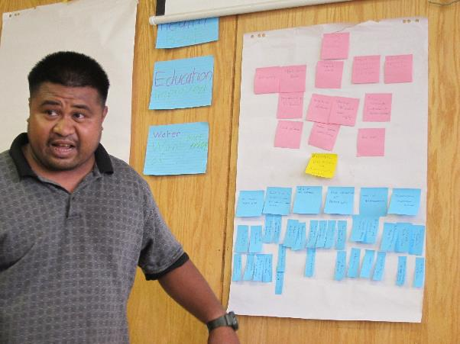

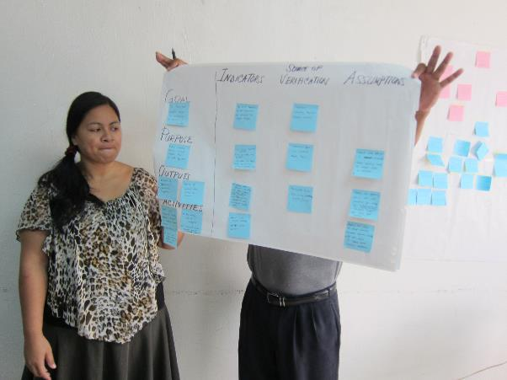

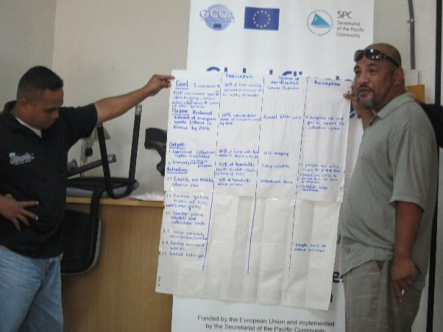

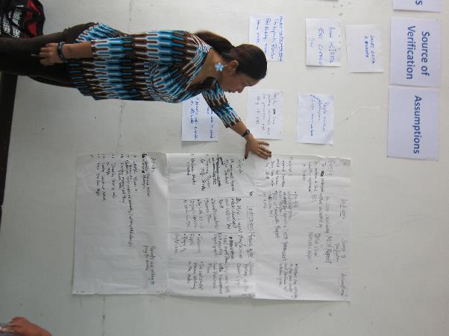

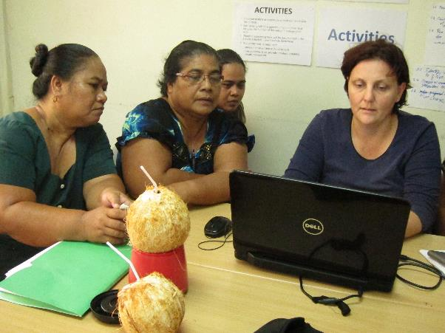**\**

**Annex 4**

# POST TRAINING EVALUATION DARTBOARDS AND COMMENTS

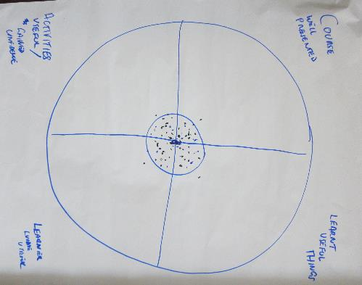

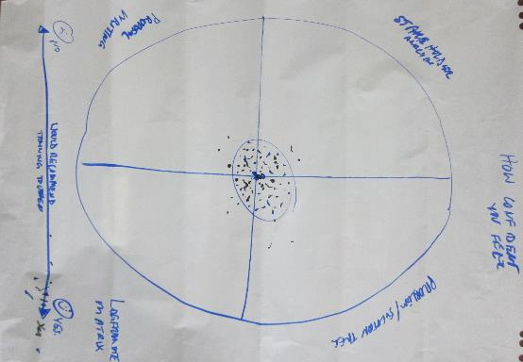

|  |  |  |
| --- | --- | --- |
| **What you liked best** | **What could be improved** | **What you want more of** |
| Develop proposals and budget for the proposals  Presentations were well performed and clear  Recommend that the course be continued  Liked the beginning of the workshop by identifying problem and finding solution  Discussions on many topics covered  Learning materials are well prepared, simple language, with consistent presentation reflecting the materials  Fully satisfied with the trainers and their teaching. Truly satisfied – bullseye!!  Logframe process and proposal development  Transforming outcomes from the problem / solution tree to the LFA matrix  The whole LFA training and methodologies used  Everything presented at the training is very useful and appreciate very much to be part of it  The workshop was fun and very interesting due to multiple aspects of it. I really enjoyed the training and felt the need of having it on the island since the capacity of constructing a project proposal is not really well-developed or well-understood. Thankyou and I hope I can use what I learned in the near future. It was all good.  I liked the problem tree  Hands on exercises  The exercises were enlightening and informative  The best lectures and materials of course the refreshments were well organised  Very well liked from beginning to end (clearly presented and explained) | Good training but make it a little bit interesting and not too long presentation and training  Equipment / materials  Time management and allocation  Indicators  Four days is too short  To improve the grant writing training in each communities | Need more training x 3  Proposal writing x 3  More refresher courses / training and also for future participants  LFM to M&E  More training and exercises x 3  Logframe matrix  Summary of proposal writing |

1. Each participant was asked to place a mark in each sector of the dartboard, with marks closer to the centre (or bullseye) indicating high level of satisfaction/agreement, and marks further away from the centre indicating less satisfaction/agreement (where marks outside the ‘frame’ of the dartboard indicate that the course ‘missed the mark’.