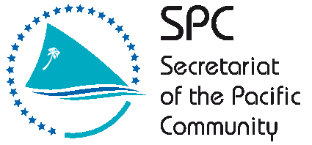

GLOBAL CLIMATE CHANGE ALLIANCE:
PACIFIC SMALL ISLAND STATES PROJECT

REPORT ON KIRIBATI CAPACITY DEVELOPMENT IN PROPOSAL PREPARATION USING THE LOGICAL FRAMEWORK APPROACH WORKSHOP
2-5 SEPTEMBER 2013

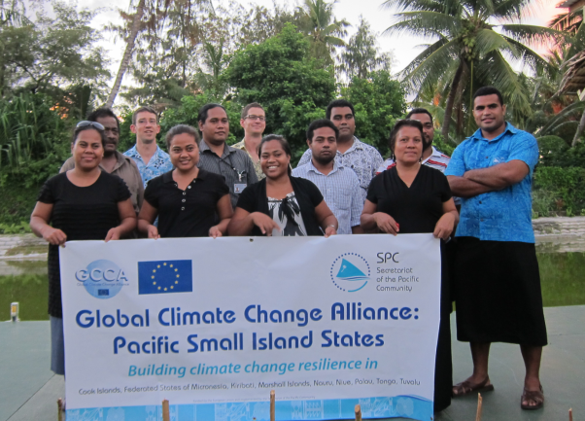

Introduction

The Global Climate Change Alliance: Pacific Small Island States (GCCA: PSIS) project is funded by the European Union (EU) and implemented by the Secretariat of the Pacific Community (SPC) in collaboration with the Secretariat of the Pacific Regional Environment Organisation (SPREP). The project budget is €11.4 million. The implementation period for the GCCA: PSIS project is from the date of signature of the agreement, 19 July 2011, to 19 November 2014.

The overall objective of the GCCA: PSIS project is to support the governments of nine Pacific smaller island states, namely Cook Islands, Federated States of Micronesia (FSM), Kiribati, Marshall Islands, Nauru, Kiribati, Palau, Tonga and Tuvalu, in their efforts to tackle the adverse effects of climate change. The purpose of the project is to promote long term strategies and approaches to adaptation planning and pave the way for more effective and coordinated aid delivery on climate change at the national and regional level.

The project approach is to assist the nine countries design and implement practical on-the-ground climate change adaptation projects in conjunction with mainstreaming climate change into line ministries and national development plans; thereby helping countries move from an ad hoc project-by-project approach towards a programmatic approach underpinning an entire sector. This has the added advantage of helping countries better position themselves to access and benefit from new sources and modalities of climate change funding, e.g. national and sector budget support.

GCCA: Capacity development in proposal preparation using the logical framework approach Project (‘LFA training’) in Kiribati

Following a regional workshop on Climate Finance and Proposal Preparation held in Apia, Samoa, 26 – 27 October 2012, and supported by the Asia-Pacific Adaptation Network (APAN), Secretariat of the Pacific Regional Environment Program (SPREP) and SPC, six of the countries (Cook Islands, Federated States of Micronesia, Marshall Islands, Nauru, Kiribati and Tuvalu) involved in the GCCA: PSIS project expressed their interest in having a national training workshop on project proposal preparation using the logical framework approach. This LFA training project responds to that expressed need. The project provides a valuable opportunity to strengthen national government staff to develop successful and integrated climate change adaptation project proposals. This will allow PSIS and donors to work together to ensure a more effective and coordinated aid delivery to address climate change at the national and regional level.

The Kiribati training workshop was delivered over 4 days (2-4 September 2013). Pacific Research and Evaluation Associates (PREA) were contracted to deliver the LFA training, based on the resources that they had previously developed and piloted in the Cooks Islands. The Kiribati Parliament conference room was originally booked to host the workshop, however, on the day before the workshop SPC was advised that an urgent Government booking request needed to be fulfilled. The first, third and fourth day of the workshop was held at the Utireirei conference room. The second day of the workshop was moved to the Kiribati Protestant Church Women’s Hall to avoid paying additional conference room hire fees at Utireirei which would be incurred because an external caterer had been engaged to provide catering services. A half-day of mentoring sessions was made available on Friday 5th September for any participants who wanted further mentoring on specific areas, or to get assistance developing project proposals following the training. Fifteen participants completed the training, representing various departments of the Kiribati Government, as well as one representative from a local NGO focusing on women’s issues (see Annex 1). There was one member of the government that attended the first day of the training, but was unable to attend the remaining days due to other commitments. Several additional participants joined the training on day 2. The facilitators spent time during breaks to ensure these participants as well those who frequently attended late (10.30) catch up with the material.

The training made use of a donor directory (Donors for Climate Change Adaptation in the Pacific) developed for SPC and SPREP. PREA also research additional donors active in the Pacific region who support PSIS and LDCs. All relevant training resources were provided to participants in hardcopy with an electronic copy provided on a USB stick for all participants.

Despite requests to have a training needs analysis survey distributed to workshop attendees in the weeks before training commenced, this did not occur. An informal review of participant knowledge and skills was carried out on the first day of the training. Most participants had no prior experience with the Logical Framework Approach, however, several had completed project proposals or been involved in some form of stakeholder analysis (community engagement). The medium term outcomes resulting from the training will be assessed through issuing a longitudinal post-training survey (3 – 6 months after the training) combined with telephone interviews. The key topics covered during the LFA training include a background on the project management cycle, a detailed look of the logical framework approach, proposal writing (informed by the LFA) and a brief summary of climate change donors active in the Pacific region. A detailed delivery plan is included in Annex 2.

The LFA training workshop was organised by SPC with support from in-country staff Mr Tebikau Tibwe, Chief Health Inspector from the Ministry of Health.

Workshop Participants

It was originally indicated that there would be around 30 people attending the training, however, due to workloads and other commitments, including the in 2013 Pacific Islands Forum in Majuro only 16 participants attended the training with 15 successfully completing the training. There was one participant who attended the first day, however, they were unable to attend the remaining three days due to busy work loads. Several of the participants needed to excuse themselves from parts of the training to attend other planned meetings etc. There was only one participant present to represent the NGO sector and there were some comments indicating that it would be good if more NGO representatives could have been invited. Two learner guides, slide packs and USB flash drives were distributed to Government staff from the newly established ministry focused on Women’s Affairs after a chance meeting with a volunteer assisting staff in that ministry.

The lack of NGO representation leads us to recommend that SPC needs to emphasise to target countries that people from the NGO sector should be specifically invited to attend. We additionally recommend that each country should have a ‘waiting list’ of attendees beyond the nominal 30 places recommended. People on the waiting list can be confirmed to participate on the first day of the workshop if other invited and confirmed members do not participate. This will help maximise the reach and benefit of the training and ensure better value for money from the invested funds.

One of the largest challenges with the delivery of training in Kiribati was starting the workshops in a timely manner. On three out of four days, the official training did not commence until after 10am due to participants not turning up in a timely manner. This delay in starting caused the remainder of the day to be more rushed and condensed than required. This likely resulted in some of the participant feedback around needing more time to cover the Logframe Matrix, budgeting and timeline activities. Future workshops to be held in Kiribati could also consider providing catering for breakfast at 8.30am instead of morning tea. This encourages participants to arrive early for breakfast so the workshop can start on time. This technique proved successful in a recent workshop conducted by another organisation in Kiribati.

Workshop Results

Mr Sanivalati Tubuna, Project Officer SPC-GCCA: PSIS, opened the workshop and gave the introductory remarks and background of the LFA training project and the role that SPC and SPREP play as implementing agency for the broader EU GCCA: PSIS project. After introductions, the two training facilitators from PREA began workshop proceedings for day 1.

Training delivery included a mix of informative presentations, large group activities to demonstrate new knowledge and skills followed by small group activities where participants were challenged to use the knowledge and skills for real-life project ideas they wanted to develop (see Annex 3 for photo of group work). There were four small project groups that worked through the LFA, representing the following project ideas:
- Increasing home gardening of traditional nutritious fruit and vegetables to combat Non-communicable diseases, increase food security and preserve traditional knowledge.
- Improving accurate and reliable weather forecasting through the establishment of a new meteorological centre and improving communication with outer islands
- Improving the accuracy and timeliness of financial reporting and acquittal services through the upgrade of the Government’s financial system.
- Improving solid waste management services at the community level to reduce litter and its associated negative environmental, social and economic impacts.

Additionally the whole of class thematic topic that was selected to work on was another suggested project for Kiribati that revolved around the issue of poor ground water quality in Tarawa with a focus on the need to address the lack of sanitary disposal of human waste using quality latrines with septic systems or plumbed into the sewer.

The facilitators moved between groups to offer support and advice where required. The presence of two facilitators was valued by participants for both the presentations and the detailed group work. Start of day and post-lunch warm-up activities were conducted to refresh participants and prepare them for learning. Each day began with a recap of the preceding day and each day ended with a re-cap of the days’ content.

PREA organised a guest presentation by Mr Mark Sayers from AusAID to reinforce the importance of using the LFA, provide tips on proposal writing and talk about the AusAID Direct Aid Program (DAP) funding. A meeting with Mr Sayers before his presentation at the workshop confirmed the need for LFA training to improve proposal writing. As experienced in other countries, there were several key faults with funding applications being received:
- proposal were not clear and concise
- the need for the project was often poorly articulated
- sections were on occasion left blank (indicating a rushed response)
- budgets were lacking detail and rigour
- proposals often did not align with donor priorities (as specified in the guidelines)

The workshop concluded on day 4 with group performances, which reflect what participants have learnt, group photo and certificate of attendance presentation conducted by Mr Sanivaliti Tubuna of SPC and XXXXXXXX from XXXXX.

Workshop Evaluation

The results of the workshop evaluation are presented as Annex 4. Only 10 participants who attended the four days completed the evaluation form due to the need to leave early or failure to attend the presentation ceremony where those who left early were going to complete the evaluation.

The Kiribati training was very successful, mirroring that of the Cook Islands and Niue delivery. The participants all had experience working in teams, and on projects and were fluent in English. This made the delivery easier, compared to that of the Marshall Islands. Notwithstanding the participants’ strong level of English, the logframe matrix was still translated into I-Kiribati.

 | KANIKINA AIKA UAIAKINAKI  [INDICATORS] | KAKOAUA  [SOURCES OF VERIFICATION] | KATAUTAU  [ASSUMPTIONS]
BOTO NI IANGO
[GOAL]
BONGANANA / MANENANA
[PURPOSE]
BWAAI AIKA A NA REKE
[OUTPUTS]
MWAKURI
[ACTIVITIES]

Nearly all the participants indicated a strong to fair degree of confidence in being able to complete the steps of the logical framework approach upon their return to work. The same level of confidence applied to being able to write a proposal. This is backed up by participants’ comments, who indicated that the most useful aspect of the course was learning about the structured process of the LFA and how this helped in preparing proposals.

The technique of creating solution trees and doing strategy analysis:

“Using and applying the LFA in project proposal development and other work related situation. E.g strategic planning, monitoring.”

“Making a project proposal that starts right from the core problems and then begin to build a good and logical proposal”

“How to write good proposal and now steps were discussed from the beginning could be followed and lead to good project. Failures and weakness [of existing practices] were noticed after conducting this training”

“Very useful to learn about the LFA and also very good to hear from the Donor who came to share their point of view”

When asked about follow up training, participants’ comments included that they would like further training on certain specific aspects of the logframe approach such as the logframe matrix, and how this fitted in with proposal writing, as well as more time on the actual proposal writing itself. Budgeting and timeline development (resource and activity scheduling) were also requested in addition to monitoring and evaluation. Verbally, a number of respondents indicated that they would have liked other staff from their workplace to have attended the training.

All of the participants indicated that they would recommend the course to their colleagues. Most participants indicated that the length of the course was too short. Some participants requested another day whilst others wanted an additional week so they had more time to absorb the content and participate.

“if training was longer, participants could have had time to lead the discussions on the design being discussed as an example”

The participants all indicated satisfaction with the delivery, and the resources provided. The following comments reflect the success of the Kiribati training delivery.

“Very much appreciate the course and it very helpful, especially to us technical staff with limited knowledge in administration and project proposal. I reckon that it maximised to all technical staff at middle management level”,

“the course is in all well delivered and structured etc. Need more ice-breakers games in intervals Two thumbs up!!”

“Thanks Martin and Damien for this few days training. I think I walk of this training as a more confident person that can apply this thinking in my area of work. Also thanks goes to Sani for all the logistical arrangements.”

“Very intensive for us to cram things into our heads Participatory approach to teaching and learning is very good. Facilitators are very efficient and effective in teaching new concepts . Contextualised to our Kiribati setting. AWSOME and thank you”.

Conclusion

The training was very successful in building the capacity and more motivation of Kiribati government staff to use the logical framework approach to design better projects, and leading to better proposals. The participants noted the benefits of thinking through projects at the design stage, rather than jumping straight to solutions or actions. There is a strong likelihood that a number of the projects that small groups worked on will be further developed into actual proposals. It will be interesting to see with the impact evaluation in several months’ time whether any proposals have been successful in receiving funding.

Annex 1 Participants List

 |  | Personal Details of trainee
First name | Surname | Job title | Organisation | Sex | Nationality | Email
Kilifi T. | O'Brien | SPC Intern/Tuvalu Secretary (Environment and Planning) | SPC/Tuvalu | M | Tuvalu | kilifiobrien@gmail.com
Elaine I. | Bwebwe | Senior Assistant Secretary | Min. of Foreign Affairs | F | Kiribati | sas@mfa.gov.ki
Tebete | England | Mineral Officer | Mineral Division (MFMRD) | F | Kiribati | tebetee@mfmrd.gov.ki
Bwebwe | Tuare | Senior project officer | MELAD | F | Kiribati | ruauab@gmail.com
Tarakabu | Tofinga | Senior Land Planner | Lands/MELAD | M | Kiribati | tarakabu.tofinga@gmail.com
Claire | Anterea | Community Officer | Kiribati Climate Action Network - NGO | F | Kiribati | canterea@gmail.com
Ueneta | Toorua | Climate Officer | Meteorological Service | M | Kiribati | uenetat@gmail.com
Kamaitia | Rubetaake | Assistant Climate Officer | Meteorological Service | F | Kiribati | rubetaake.kamaitia@gmail.com
Rutiana | Kareba | Agricultural Assistant | Agriculture & Livestock Division | F | Kiribati | ruutngai@gmail.com
Tetokira | Kimereti | Economist | Planning Office, MFED | M | Kiribati | tkirimereti@mfep.gov.ki
Roonga | Iabeti | Station Technical Officer | Meteorological Service | M | Kiribati | lonatia@gmail.com
Tebikau | Tibwe | Chief Health Inspector | Min of Health | M | Kiribati | tnoran@gmail.com
Tuake | Teena | Senior Fisheries Officer | Fisheries Division | M | Kiribati | tuaket@fisheries.gov.ki
Bibiana | Bureimoa | Senior Curriculum Officer | Min of Education/Curriculum Division | F | Kiribati | bbbkaiea@gmail.com
Ane | Teiaua | Lecturer | KTC (MoE) | F | Kiribati | ane.teiana@gmail.com
Tokabai | Bauro | Assistant Mineral Officer | Mineral Division (MFMRD) | F | Kiribati

Annex 2 Workshop Agenda
Secretariat of the Pacific Community

Kiribati

Global Climate Change Alliance: Pacific Small Island States

PROPOSAL PREPARATION USING THE LOGICAL FRAMEWORK APPROACH WORKSHOP

Delivery plan summary
 | Task / Topic
Day 1 | Welcome  Gathering group knowledge  Introduction to the LFA  Project Management Cycle  Step 1. Stakeholder Analysis  Step 2. Problem analysis
Day 2 | Step 2. Problem analysis continued  Step 3. Solution Analysis  Step 4. Strategy Analysis – Selecting solutions  Step 5. Logframe Matrix
Day 3 | Step 5: Logframe Matrix continued  Step 6: Activity Scheduling
Day 4 | Step 7: Resource Scheduling  Proposal Writing  Donor agencies  Celebration and group performances  Final feedback and evaluation
Day 5 | Half-day mentoring session

Annex 3
Photos of workshop activities

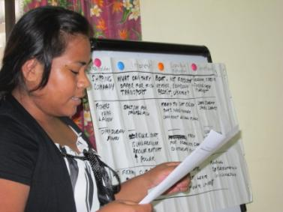

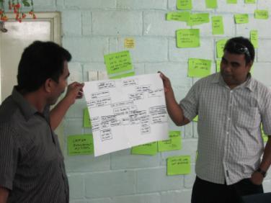
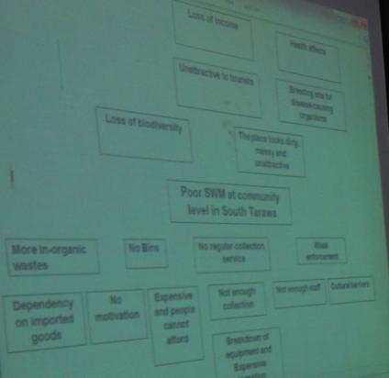

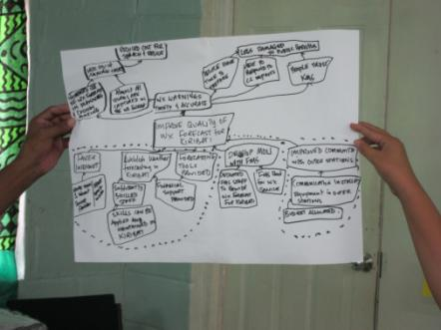

Annex 4

POST TRAINING EVALUATION FORM – KIRIBATI
Completed by 10 participants
The training was well structured | 7 | 3 |  |  |  |  |  | The training was poorly structured

The activities gave me the confidence that I can apply the knowledge in my work | 8 | 1 |  |  |  |  |  | The activities did not give me confidence that I can apply the knowledge in my work

I found the learner guide useful | 9 | 1 |  |  |  |  |  | I did not find the learner guide useful

I learnt things that will be useful to my work | 9 | 1 |  |  |  |  |  | I did not learn things that will be useful to my work

The course was well presented | 9 | 1 |  |  |  |  |  | The course was poorly presented

The facilitators made the material enjoyable | 7 | 3 |  |  |  |  |  | The facilitators did not make the material enjoyable

For each of the following, please rate your level of confidence in being able to undertake the following steps of the logical framework approach when you get back to your job.
Very confident |  |  |  |  |  |  |  | Not at all confident
Stakeholder analysis | 7 | 3
Problem analysis | 8 | 2
Solution analysis | 7 | 3
Logframe matrix | 5 | 4 | 1

I am confident that I can put together a good project proposal | 2 | 8 |  |  |  |  |  | I am not confident that I can put together a good project proposal

I would recommend this course to my colleagues | 7 | 2 |  |  |  |  |  | I would not recommend this course to my colleagues

Four days for the course was: | About right | 3
 | Too short | 7
 | Too long

What was the most useful thing you learnt on this course?
Everything from day 1 to the last day. I found them very useful.
How to write good proposal and now steps were discussed from the beginning could be followed and lead to good project. Failures and weakness were noticed after conducting this training
Lograme matrix
Making a project proposal that starts right from the core problems and then begin to build a good and logical proposal
most useful thing that I learned is using logical framework approach in doing project proposal and planning
The overall concepts of the LFA
The overall purpose that is how to write a good proposal
The technique of creating solution trees and doing strategy analysis
Using and applying the LFA in project proposal development and other work related situation. E.g strategic planning, monitoring.
Very useful to learn about the LFA and also very good to hear from the Donor who came to share their point of view

The course would have been more effective if:
Could done a devoted more time on the practical side of the things
Having have time with consideration specific donor guidelines
It could be longer. Say 5 days or more
LF Matrix
More days given
More time to cover the LF Matrix
Need to have a longer time
spend more time on specific group activities especially in developing project proposals and applying lfa steps.
The days extended to 2 weeks so we could slowly go through each topic
Was spread out over two weeks rather than just 4 days

Which topic(s), if any, do you want follow-up training on?
development of logframe work and costing
Log Frame Matrix
Log frame matrix
Log frame matrix. I need to learn more
Monitoring and evaluation and the proposal write-up itself. If we can spend d project proposal to be checked by martin or Damien this will be good.
more on developing LFM, timeframe and budgeting
More on the last steps of LFA
stakeholder analysis, budgeting and scheduling (the details aspects of the training)
Sustainability and clarification between profit making projects and non-profit making oritented projects

Do you have any further comments or feedback about any aspects of the training?
Everything is good, at least have an idea of how to make a productive and or successful proposal.
Facilitators are smart and efficient to carry out the training.
if training was longer, participants could have had time to lead the discussions on the design being discussed as an example
Need to invite more NGO and other communities
Thanks Martin and Damien for this few days training. I think I walk of this training as a more confident person that can apply this thinking in my area of work. Also thanks goes to Sani for all the logistical arrangements.
the course is in all well delivered and structured etc. Need more ice-breakers games in intervals Two thumbs up!!
The overall training content….. Is satisfactory
Very much appreciate the course and it very helpful, especially to us technical staff with limited knowledge in administration and project proposal. I recon that it maximized to all technical staff at middle management level.
Vey intensive for us to cram things into our heads Participatory approach to teaching and learning is very good. Facilitators are very efficient and effective in teaching new concepts . Contextualized to our Kiribati setting. AWSOME and thank you.

