GLOBAL CLIMATE CHANGE ALLIANCE:
PACIFIC SMALL ISLAND STATES PROJECT

REPORT ON LOGICAL FRAMEWORK APPROACH WORKSHOP PART II IN KIRIBATI

5 – 10 JUNE 2015

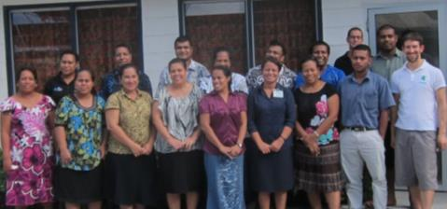

Introduction

The Global Climate Change Alliance: Pacific Small Island States (GCCA: PSIS) project is funded by the European Union (EU) and implemented by the Secretariat of the Pacific Community (SPC) in collaboration with the Secretariat of the Pacific Regional Environment Programme (SPREP). The project budget is €11.4 million. The implementation period for the GCCA: PSIS project is from 2011 to 2015.

The overall objective of the EU funded GCCA: PSIS project is to support the governments of nine Pacific smaller island states, namely Cook Islands, Federated States of Micronesia (FSM), Nauru, Marshall Islands, Niue, Kiribati, Palau, Tonga and Tuvalu, in their efforts to tackle the adverse effects of climate change. The purpose of the project is to promote long term strategies and approaches to adaptation planning and pave the way for more effective and coordinated aid delivery on climate change at the national and regional level.

The project approach is to assist the nine countries design and implement practical on-the-ground climate change adaptation projects in conjunction with mainstreaming climate change into line ministries and national development plans; thereby helping countries move from an ad hoc project-by-project approach towards a programmatic approach underpinning an entire sector. This has the added advantage of helping countries better position themselves to access and benefit from new sources and modalities of climate change funding, e.g. national and sector budget support.

Between March 2013 and May 2014, training in proposal preparation using the logical framework approach was delivered to 9 Pacific Small Island countries, including all four states of the Federated States of Micronesia. The results of a longitudinal survey issued three months after participants attended the training indicated an interest in follow-up training on the LFA in additional to training on monitoring and evaluation. Several countries also made direct requests to SPC for additional capacity building training in project design.

SPC responded to the longitudinal survey feedback and country requests by announcing the delivery of follow-up training on the LFA and project monitoring in five Pacific Small Island States.

GCCA: PSIS Capacity development in the Logical Framework Approach and Project Monitoring Part II (‘LFA Workshop Part II’) in Kiribati

The second LFA Workshop Part II was held in Tarawa, Kiribati between the 5th and 10th of June 2015. The workshop was delivered by two facilitators from Pacific Research and Evaluation Associates (PREA). The training workshop was delivered over 4 days. A summary agenda documenting the main topics covered during the training is presented in Annex 1.

The objective of the workshop was to:
- Apply the Logical Framework Approach to develop a robust logframe matrix
- Develop an accurate timeline and budget for projects, based on identifying the tasks and costs to implement activities in the logframe matrix.
- Develop a monitoring plan and understand how to monitor projects as they are implemented.

The LFA training workshop was organised by SPC with support from in-country staff. PREA liaised with Mr Choi Yeeting and Mr Michael Foon, from Kiribati Office of the President (OB), to identify the specific training needs and projects to work on during the training in Kiribati. All relevant training resources were provided to participants in hardcopy with an electronic copy provided on a USB stick.

The workshop was attended by 15 participants from a range of Government departments/ministries. (see Annex 2 for a list of workshop participants).

Ms Titilia Rabuatoka, SPC-GCCA:PSIS Project Liaison Assistant provided welcoming remarks and spoke about the background of the SPC-GCCA:PSIS Project before the workshop officially started.

After introductions, the two training facilitators from PREA began workshop proceedings.

Workshop Results

“I've learned to use tools in identifying and developing a more effective proposal or projects”.

Training delivery included a mix of informative presentations, large group activities to demonstrate new knowledge and skills followed by small group activities where participants were challenged to use the knowledge and skills for real-life project ideas they wanted to develop (see Annex 3 for photo of group work). The whole-of-class activity focussed on a semi-fictional case study to implement a renewable energy project in a small island state. There were five six project groups that worked through the LFA, representing the following project ideas:
- Improving stockpile/storage and access to pharmaceuticals in Kiribati
- Improving timeliness and accuracy of weather forecasting for disaster risk reduction
- Developing e-learning facilities on outer islands to improve teacher capacity
- Improving bulky waste management in Tarawa
- Improved traditional knowledge and protected site documentation
- Improved access to adequate supply of PUB water in South Tarawa

The participants were very interactive in their small group projects throughout all the steps of the LFA. The level of engagement was much higher than the previous training in Kiribati (August 2013).

The workshop concluded on day four with Mrs XXX, Secretary XXXX, issuing certificates of participation to attendees.

Workshop Evaluation

The detailed results of the workshop evaluation are presented as Annex 4. Twelve participants who attended the workshop completed a post-workshop evaluation form. In addition, a ‘dartboard’ evaluation was undertaken (see Annex 5). The results of the dartboard indicate that the training was very well received and that the participants are confident in the use of the LFA.

All respondents indicated that the course was well presented and that they learnt things that would be useful to their work. Respondents also indicated that the learner guide was useful and that the activities gave them the confidence to apply the knowledge in their work.

All respondents indicated a strong degree of confidence in being able to design a good project. All respondents indicated that they would be able to complete all the steps of the LFA.

During the training, one participant noted that he had attended LFA training many years ago delivered by AusAID but he found this training was more useful in developing skills in applying the LFA through the mix of presentations followed by hands-on activities.

“I now understand how to do a LFA and it will help me a lot in carrying out my activities at work.”

Respondents indicated that the training could be improved if there was more time. One respondent suggested that more time should be spent on completing the activities, and the training could be over 5 days.

The most popular topics for further training and development were:
- Budgeting and finance (x4)
- Monitoring and evaluation, including a whole training on ‘Field Task’ open source survey app (x3)
- Refresher course
- Software solutions to help complete the LFA
- Logframe matrix
- Project management for implementation

There was strong interest in monitoring and evaluation, and in the demonstration of the smartphone survey application ‘Field Task’.

There was interest in using Gannt chart software in the training, as well as further training in Gannt chart software.

“Training was interesting involving 2 facilitators at different time of lesson. It helps to change the mood to the participants. Exercises are realistic/practical to my daily work. Eye opening, ice breaker also interesting. Thanks very much”

All respondents indicated that they would recommend the course to their colleagues. Seven respondents indicated the length of the training was about right, and five indicated it was too short.

The medium term outcomes resulting from the training will be assessed through issuing a longitudinal post-training survey (3 – 6 months after the training) combined with telephone interviews.

Conclusion
The training was very successful in continuing to build capacity of Kiribati government staff in project proposal preparation. The participants were engaged throughout the four days of training.

One participant from the first round of training in Kiribati came to the workshop to inform the facilitators that she had found the training very useful to her work, and to inform that she had developed three successful funding proposals.

PREA also met with the Director of Planning at National Economic Planning Office (NEPO), who advised that he had used the training resources from the first round of LFA training to deliver ‘in-house’ training to 11 NEPO staff. The Director noted that the training resources were very easy to use and understand.

Participants indicated that the training would be very useful to both their work and proposal development.

Overall, this round of training in Kiribati was very successful and demonstrates the benefits of having experienced and motivated participants working on real projects that they can work on and develop during the training. The strong level of engagement in group discussion and feedback was beneficial to participants learning from each other.

The impact evaluation in several months’ time will determine whether any of the projects worked on during the training will be developed up into real proposals.

ANNEX 1. Workshop Agenda

Proposal preparation using the Logical Framework Approach - Part II

Workshop Objective
To build participant capacity in applying the logical framework approach to designing projects, and to build capacity in project monitoring. More specifically at the end of this training programme, participants will be able to:
- apply the Logical Framework Approach to develop a robust logframe matrix;
- develop an accurate timeline and budget for projects, based on identifying the tasks and costs to implement activities in the logframe matrix; and
- develop a monitoring plan and understand how to monitor projects as they are implemented.

Workshop Schedule
Day 1 | Day 2
Official opening  Introduction to the Logical Framework Approach  Step 1. Situation Analysis  Step 2. Stakeholder analysis  Step 3. Problem analysis  Step 4. Solution analysis | Step 5. Strategy analysis  Step 6. Logframe matrix
Day 3. | Day 4
Step 6. Logframe matrix  Monitoring your project | Step 7. Timeline  Step 8. Budget  Workshop evaluation  Certificate presentation

Annex 2 Participants List
Workshop on proposal preparation using the Logical Framework Approach
5-10 June 2015, Tarawa, Kiribati
No. | Name | Gender | Job title | Organisation | Email | Phone (+686)
1 | Ane Teiaua | F | Lecturer | KTC (MOE) | ane.teiaua@gmail.com | 28158
2 | Tenikarawa Aiaimoa | F | Lecturer | KTC (MOE) | tenikarawa@gmail.com | 28158 / 50453
3 | Thomas Zackious | M | Acting Forecaster | KMS (MET) | thomasgzackious@gmail.com | 25444
4 | Mauna Eria | M | Acting Climate Officer | OB | meanruti@gmail.com | 25444
5 | Bweneata Kaoti | F | Bulky & E-waste Project Officer | MELAD | bweneataK@environment.gov.ki ; Kaoti.bene@gmail.com | 28425 / 28000 / 68037
6 | Tirae Tabee | F | Senior Fisheries Assistant | MFMRD | tiraet@fisheries.gov.ki | 28061
7 | David Teaabo | M | Smaller Island States & Pacific Regionalism Coordinator | MFA | dopp@mfa.gov.ki | 21342 / 67370
8 | Ioana Taakau | F | Chief Pharmacist | MHMS | ioana.taakau@gmail.com | 28100 / 66225
9 | Rakera Arataake | F | Project Officer | MFMRD | r.taretiita@gmail.com
10 | Riteta Iorome | M | Water Engineer | MPWU | ioromekuaravete@mpwu.gov.ki | 69298
11 | Kaotitaake Kokoria | M | Senior Rural Development Officer | MIA | srdo@internalaffairs.gov.ki
12 | James Teaero | M | Assistant Secretary | MIA | as@internalaffairs.gov.ki | 21092
13 | Reeti Onorio | F | Director, Tourism | MCTT | ronorio@kiribatitourism.gov.ki | 26003
14 | Rita Tokataake | F | Rural Development Officer | MIA | rtokataake@internalaffairs.gov.ki | 21092 / 22536 / 90066
15 | Bwebwe Tuare | F | Senior Project Officer | MELAD | ruauab@gmail.com | 28211
16 | Takena Redfern | F | Senior Crop Research Officer | MELAD | taakena@ald.gov.ki ; redfern.takena@gmail.com | 28108 / 64290
17 | Tiuti Biribo | M | Tourism Officer | MCTT | tbiribo@kiribatitourism.gov.ki | 26003
18 | Maiango Enota | F | Acting Water & Sanitation Superintendent | MPWU | mtavita2@gmail.com | 26192

Annex 3
Photos of workshop activities

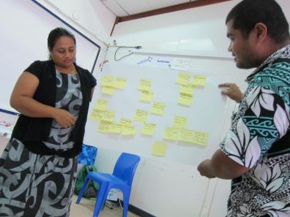

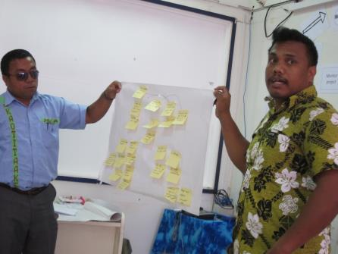

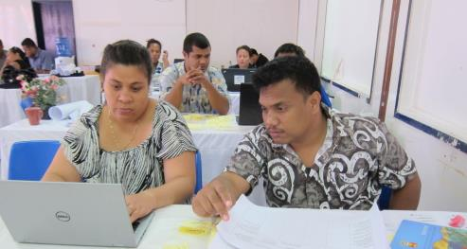

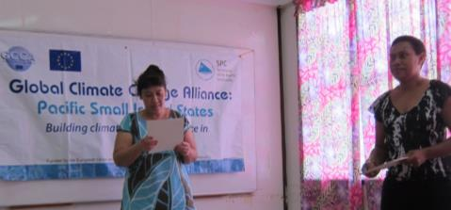

Annex 4

LFA PART 2 - POST TRAINING EVALUATION FORM KIRIBATI
12 participants completed the post-workshop questionnaire

The training was well structured | 11 | 1 |  |  |  |  |  | The training was poorly structured

The activities gave me the confidence that I can apply the knowledge in my work | 7 | 5 |  |  |  |  |  | The activities did not give me confidence that I can apply the knowledge in my work

I found the learner guide useful | 11 | 1 |  |  |  |  |  | I did not find the learner guide useful

I learnt things that will be useful to my work | 10 | 2 |  |  |  |  |  | I did not learn things that will be useful to my work

The course was well presented | 9 | 3 |  |  |  |  |  | The course was poorly presented

The facilitators made the material enjoyable | 12 |  |  |  |  |  |  | The facilitators did not make the material enjoyable

For each of the following, please rate your level of confidence in being able to undertake the following steps of the logical framework approach when you get back to your job.
Very confident |  |  |  |  |  |  |  | Not at all confident
Problem analysis | 5 | 7
Solution analysis | 5 | 7
Logframe matrix | 6 | 6
Project monitoring | 5 | 6 | 1
Timeline | 6 | 6
Budget | 6 | 6

I am confident that I can design a good project | 5 | 7 |  |  |  |  |  | I am not confident that I can design a good project

I would recommend this course to my colleagues | 12 |  |  |  |  |  |  | I would not recommend this course to my colleagues

Four days for the course was: | About right | 7
 | Too short | 5
 | Too long

What was the most useful thing you learnt on this course?
Ability to come up with a problem and solution tree- 2 thumbs up!
I now understand how to do a LFA and it will help me a lot in carrying out my activities at work
I've learned to use tools in identifying and developing a more effective proposal or projects
LFM
logframe matrix
Mostly the topics covered in the training are very useful
risk management, logical framework matrix, budget, monitoring and evaluation
Solution and problem tree, logframe matrix, dartboard
The process involved in the LFA, especially the logframe matrix and M&E
The systematic approach- 8 steps, budgeting- indirect/direct costs, goods and services, scheduling- task assumptions
Understand how to use logframe matrix as well as breaking down the activities to task

The course would have been more effective if:
Had a case study of a real project from Kiribati as in Toktoklau
If all activities are provided with examples
If I had attended Part 1
It could be more than 4 days
It was conducted for 5 days
More people are participants or involved in the training
No comments everything is perfect
Prodoc and CBA
We can use gannt chart software
Which topic(s), if any, do you want follow-up training on?
All good
Budget, it is the most critical part of the project proposal
Budgeting / Problem Trees
Gantt chart
I would suggest that more staff members especially from Ministry of Internal Affairs (Rural Planning Division) are incorporated in the training
Logic framework matrix
Proposal development using problem and solution tree
Risk management plan, evaluation plan
the use of the Gantt chart

Do you have any further comments or feedback about any aspects of the training?
For the next workshop please invite us (through govt)
Hands on activities to be given more time
Smartphone survey skill, more time for Gantt chart
Thanks for the training I gained a lot of the things in project proposal
This training should be conducted every year as a refresher training
training was interesting involving 2 facilitators at different time of lesson. It helps to change the mood to the participants. Exercises are realistic/practical to my daily work. Eye opening, ice breaker also interesting. Thanks very much

Annex 5 – Post-workshop Dartboard
The first dartboard shows the participants rating of the workshop presentations & facilitators, resources, length and activities.
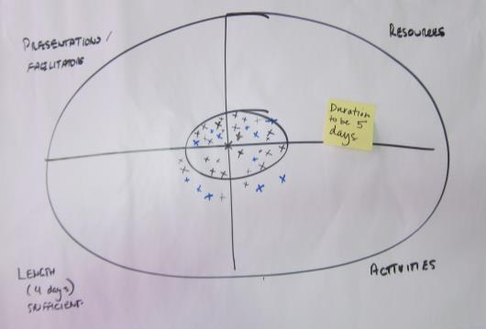
The second dartboard shows the level of confidence of completing the LFA steps.
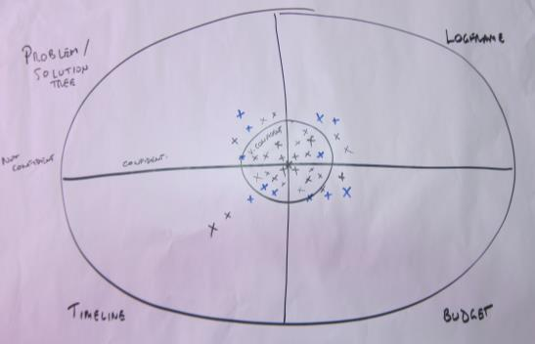

Tuvalu, Palau, Niue, Tonga, Kiribati

