

**SECRETARIAT OF THE PACIFIC COMMUNITY**

**GLOBAL CLIMATE CHANGE ALLIANCE:**

**PACIFIC SMALL ISLAND STATES PROJECT**

**FUNDED BY THE EUROPEAN UNION**

**REPORT ON CHUUK CAPACITY DEVELOPMENT IN PROPOSAL PREPARATION USING THE LOGICAL FRAMEWORK APPROACH WORKSHOP**

**5 May – 8 May 2014**

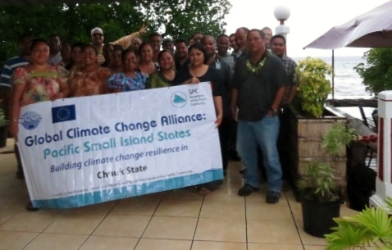

**Introduction**

The Global Climate Change Alliance: Pacific Small Island States (GCCA: PSIS) project is funded by the European Union (EU) and implemented by the Secretariat of the Pacific Community (SPC) in collaboration with the Secretariat of the Pacific Regional Environment Programme (SPREP). The project budget is €11.4 million. The implementation period for the GCCA: PSIS project is from the date of signature of the agreement, 19 July 2011, to 19 November 2014.

The overall objective of the EU funded GCCA: PSIS project is to support the governments of nine Pacific smaller island states, namely Cook Islands, Federated States of Micronesia (FSM), Nauru, Marshall Islands, Niue, Kiribati, Palau, Tonga and Tuvalu, in their efforts to tackle the adverse effects of climate change. The purpose of the project is to promote long term strategies and approaches to adaptation planning and pave the way for more effective and coordinated aid delivery on climate change at the national and regional level.

The project approach is to assist the nine countries design and implement practical on-the-ground climate change adaptation projects in conjunction with mainstreaming climate change into line ministries and national development plans; thereby helping countries move from an *ad hoc* project-by-project approach towards a programmatic approach underpinning an entire sector. This has the added advantage of helping countries better position themselves to access and benefit from new sources and modalities of climate change funding, e.g. national and sector budget support.

**GCCA: PSIS Capacity development in proposal preparation using the logical framework approach Project (‘LFA training’) in Chuuk**

Following a regional workshop on Climate Finance and Proposal Preparation held in Apia, Samoa, 26 – 27 October 2012, and supported by the Asia-Pacific Adaptation Network (APAN), Secretariat of the Pacific Regional Environment Program (SPREP) and SPC, all of the countries involved in the GCCA: PSIS project expressed their interest in having a national training workshop on project proposal preparation using the logical framework approach. FSM made a request to the GCCA: PSIS project to hold separate trainings in Yap, Kosrae and Chuuk in addition to the national training held in Pohnpei in February 2014. This particular training in Chuuk responds to that expressed need and represents the final workshop as part of this series.

The Coping with Climate Change in the Pacific Island Region program (CCCPIR) implemented in partnership with Deutsche Gesellschaftfür Internationale Zusammenarbeit (GIZ) on behalf of the German Federal Ministry for Economic Cooperation and Development (BMZ) has assisted with the provision of logistical support for the training in Chuuk.

The training provides a valuable opportunity to strengthen national government staff to develop successful and integrated climate change adaptation project proposals. This will allow PSIS and donors to work together to ensure a more effective and coordinated aid delivery to address climate change at the national and regional level.

The Chuuk training workshop was delivered over 4 days (5 May – 8 May 2014). Pacific Research and Evaluation Associates (PREA) were contracted to deliver the LFA training, based on the resources that they had previously developed and piloted in the Cooks Islands. The workshop was held at the Truk Stop Hotel Conference Room and was attended by 28 participants (participant numbers tended to drop to around 18 in the early afternoon).

The training made use of a donor directory (Donors for Climate Change Adaptation in the Pacific) developed for SPC and SPREP. PREA also researched additional donors active in the Pacific region who support PSIS. All relevant training resources were provided to participants in hardcopy with an electronic copy provided on a USB stick to most participants (there were not enough USB sticks at the training but arrangements are planned to provide extra USB sticks at a later date). Additional outputs (problem tree, solution tree and logframe matrix) created during the workshop were also included on the USB stick.

The key topics covered during the LFA training include a background on the project management cycle, a detailed look of the logical framework approach, proposal writing (informed by the LFA) and a brief summary of climate change donors active in the Pacific region. A detailed delivery plan is included in Annex 1.

The LFA training workshop was organised by SPC through Ms Victorina Loyola-Joab(SPC GCCA: PSIS) with support from the Federated States of Micronesia national government through Ms Belinda Hadley (SPC FSM National Coordinator, OEEM) and Brad Mori (Chuuk EPA). Mr Nowell Petrus, from the Overseas Development Assistance unit of the Governor’s Office, provided an official welcome on behalf of the Chuuk State. Ms Victorina Loyola-Joab also provided opening remarks, providing context for the training workshop, and background to the SPC GCCA: PSIS programme.

After introductions, PREA began workshop proceedings for day 1. The training generally commenced at 9 am and finished at 4 pm on each training day. As noted previously, participant numbers would decrease after lunch but there were generally around 15-20 participants remaining till the scheduled end of the training. The participants worked very well during the group work and the facilitators were able to keep to the planned schedule.

**Workshop Participants**

The training was well attended over the four days with 28 participants actively participating. The participants represented various departments of the Chuuk State Government and some NGOs (see Annex 2). Learner guides and slide packs were distributed to all participants. USB sticks with learner resources and other material developed during the training (group problem tree and matrix) were provided to 14 participants, and the material was copied onto other people’s personal USB drives. A list of participants who did not receive USB sticks was made for later follow-up and delivery.

**Workshop Results**

Training delivery included a mix of informative presentations, large group activities to demonstrate new knowledge and skills followed by small group activities where participants were challenged to use the knowledge and skills for real-life project ideas they wanted to develop (see Annex 3 for photo of group work). There were five small project groups that worked through the LFA, representing the following project ideas:

1. Reducing coastal erosion in Eot
2. Improving fisheries management in the coastal fishery
3. Reducing the prevalence of diabetes in Chuuk
4. Providing reliable and affordable household energy to rural areas
5. Improving customer service to tourists and tourists’ experience in Chuuk

The whole-of-class activity focussed on increasing staple crop production in Chuuk.

The facilitators moved between groups to offer support and advice where required. The presence of two facilitators was valued by participants for both the presentations and the detailed group work.

Wisney Nakayama, from Chuuk Conservation Society, made a presentation from a donor’s perspective on Day 3 of the training. This was followed by a question and answer session.

The workshop concluded on day four with a certificate of attendance presentation conducted by Ms Belinda Hadley and Ms Victorina Loyola-Joab.

**Workshop Evaluation**

The results of the workshop evaluation are presented as Annex 4. Twenty participants who attended the four days completed the evaluation form.

The Chuuk training was successful with active participation from 28 participants. The participants valued the opportunity to develop project ideas as demonstrated by them working during breaks. This indicates that they valued the learning opportunity the course presented. There was a good amount of participation, discussion and critical feedback offered in response to project group presentations. Importantly, the participants seemed to have fun in the training, with a considerable amount of laughter and positive reinforcements amongst themselves during group presentations (the cry of ‘excellent’ was repeated by participants following their group presentations).

All respondents reported that they learnt new useful knowledge and skills at the workshop. Participants indicated that the activities and learner guide were useful. Overall, participants found the course well presented, as indicated by post-workshop questionnaire results provided in Annex 4 (and excerpts from comments below).

***What participants found most useful***

*Help me understand what was needed to start writing the proposal*

*Everything is useful but I am new to some words that delay my understanding*

*I learned a lot of important things. LFA tool, the most comprehensive, useful tool for writing a project proposal*

*Problem tree, solution tree, logframe matrix*

*Logframe matrix*

*The steps: stakeholder, problem, solution and logframe matrix*

In general, respondents indicated having confidence to undertake the key steps of the LFA, and to put this together into a proposal. As such, the key outcome of the training has been met.

Respondents’ comments indicated that the main topics for follow up training were:

1. Logframe matrix
2. Proposal writing

A number of respondents indicated that they wanted follow-up LFA training.

Participants also indicated that they would recommend the training to their colleagues. This supports the finding that the participants found the course useful.

The following comments reflect the success of the Chuuk training delivery.

*Excellent job, hope to see you again in Chuuk*

*All is good, excellent!*

Three participants took up the offer of mentoring on the optional fifth day of training. A number of participants also indicated that they were looking to develop their small group project into full proposals in the near future and that they would send them to the PREA facilitators to review.

The medium term outcomes resulting from the training will be assessed through issuing a longitudinal post-training survey (3 – 6 months after the training) combined with telephone interviews.

**Conclusion**

The proposal writing training was successful in building capacity and motivation of Chuuk State government staff and NGO members to use the logical framework approach to design projects and inform the preparation of proposals. A number of the small project group logframes are likely to be developed into proposals which demonstrates the benefits of the training. The impact evaluation in several months’ time will determine if the projects worked on during the training were developed up into real proposals. Overall, the Chuuk training was very successful and provided a great ending to the LFA training series.

**Annex 1 Workshop Agenda**

**Secretariat of the Pacific Community**

**Chuuk**

**Global Climate Change Alliance: Pacific Small Island States**

**PROPOSAL PREPARATION USING THE LOGICAL FRAMEWORK APPROACH WORKSHOP**

*Delivery plan summary*

|  |  |
| --- | --- |
|  | Task / Topic |
| Day 1 | Welcome  Gathering group knowledge  Introduction to the LFA  Project Management Cycle  Step 1. Stakeholder Analysis  Step 2. Problem Analysis |
| Day 2 | Step 2. Problem Analysis continued  Step 3. Solution Analysis  Step 4. Strategy Analysis – Selecting solutions  Step 5. Logframe Matrix |
| Day 3 | Step 5: Logframe Matrix continued  Step 6: Activity Scheduling |
| Day 4 | Step 7: Resource Scheduling  Monitoring and Evaluation  Proposal Writing  Donor agencies  Group Performances  Certificate Presentation  Final feedback and evaluation |

**Annex 2 Participants List**

|  |  |  |  |  |
| --- | --- | --- | --- | --- |
| **Name** | **Position/Job Title** | **Organisation** | **Email** | **Telephone** |
| Al-Pacino J Petewon |  | HPO | [lasugar76@gmail.com](mailto:lasugar76@gmail.com) |  |
| Anerit Mailo | Archeological Field Assistant | HPO | [mailoanerit9@gmail.com](mailto:mailoanerit9@gmail.com) |  |
| Anesty Joseph Mori |  | Brothers & Sisters Association of Parem | [anestyjo9@gmail.com](mailto:anestyjo9@gmail.com) |  |
| Berden Berdon |  | HPO Chuuk |  | 932-3269 |
| Brad Mori |  | EPA | [brad_mori@hotmail.com](mailto:brad_mori@hotmail.com) |  |
| Concy Ruben |  | Nien Nomusofo System |  | 932-4779 |
| Dayson Marar | Environmental Educator | EPA | [daysonmarar@gmail.com](mailto:daysonmarar@gmail.com) |  |
| Enjoy Rain | Marine Coordinator |  | [rain.enjoy@yahoo.com](mailto:rain.enjoy@yahoo.com) |  |
| Graceful Enlet |  | Nenono Association | [qenlet@hotmail.com](mailto:qenlet@hotmail.com) |  |
| Justin Fritz |  | MRCS-Chuuk | [fritzjustin5@gmail.com](mailto:fritzjustin5@gmail.com) |  |
| Kalvin Assito |  | COM-CRE-CRD | [kassito97@gmail.com](mailto:kassito97@gmail.com) |  |
| Katherin Bisalen | Accounts Clerk | COM-CRE | [bisalenaj@gmail.com](mailto:bisalenaj@gmail.com) |  |
| Ketsen Haregaichig |  | Fin Nomusofo System | [ketsen@pacificsbdc.com](mailto:ketsen@pacificsbdc.com) |  |
| Kichy Joseph |  | Romanian Conservation Society | [tongeichuuk@gmail.com](mailto:tongeichuuk@gmail.com) |  |
| Leon Fred | Mayor / Udot | Udot |  | 931-1442 |
| Leonardo Matto Erra | Tobacco Coordinator | Division of Public Health | [lerra@fsmhealth.fm](mailto:lerra@fsmhealth.fm) |  |
| Mertha Siren Mori |  | Environmental Health & Sanitation | [m_jero07@hotmail.com](mailto:m_jero07@hotmail.com) |  |
| Moria Shomour | NCD Program Coordinator | Division of Public Health | [mshomour@fsmhealth.fm](mailto:mshomour@fsmhealth.fm) |  |
| Nowell Petrus |  | Governor's Office | [nowell.petrus@yahoo.com](mailto:nowell.petrus@yahoo.com) |  |
| Pastor Suzuki |  | Oneisom Conservation Society |  |  |
| Peter Aten | Chief | C&I | [peteraten@yahoo.com](mailto:peteraten@yahoo.com) |  |
| Raymond Willy | Farmer |  |  | 932-7124 |
| Riteioshy Timothy | Weno | Weno Municipal Office |  |  |
| Sairos Semes | Weno | Weno Municipal Office |  |  |
| Sally S Poll |  | Chuuk Women's Council |  | 330-8397 |
| Tekson Kofot |  | HPO Chuuk |  | 932-5213 |
| Valerio Manuel |  | Agriculture |  | 320-2756 |
| Wisney Nakayama |  | Chuuk Conservation Society | [wisneynakayama@gmail.com](mailto:wisneynakayama@gmail.com) |  |

**Annex 3**

**Photos of workshop activities**

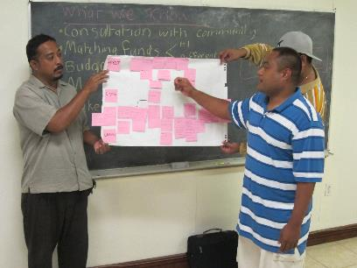

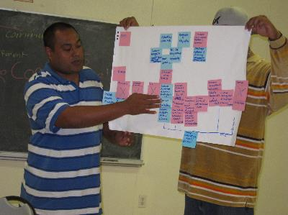

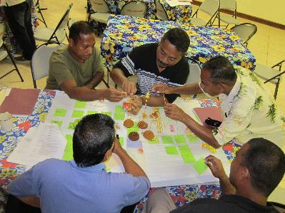

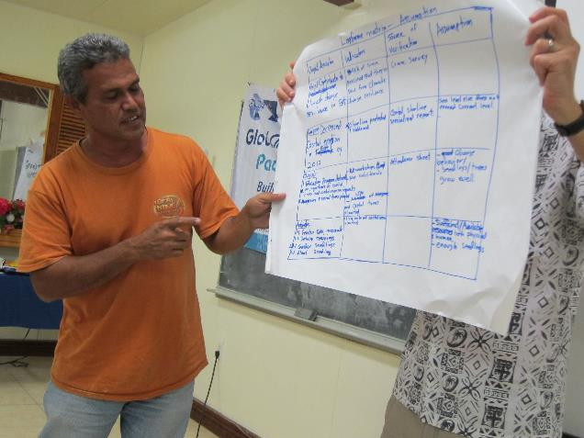

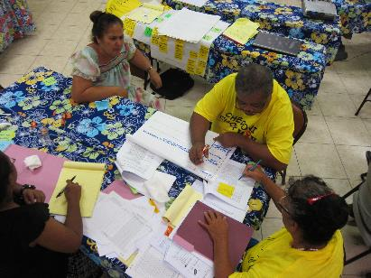

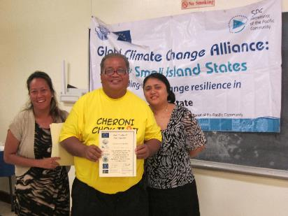

**Annex 4**

# POST TRAINING EVALUATION FORM – Chuuk

**Completed by 20 participants**

|  |  |  |  |  |  |  |  |  |
| --- | --- | --- | --- | --- | --- | --- | --- | --- |
| The training was well structured | 18 | 2 | 🞎 | 🞎 | 🞎 | 🞎 | 🞎 | The training was poorly structured |

|  |  |  |  |  |  |  |  |  |
| --- | --- | --- | --- | --- | --- | --- | --- | --- |
| The activities gave me the confidence that I can apply the knowledge in my work | 13 | 4 | 2 | 🞎 | 🞎 | 🞎 | 🞎 | The activities did not give me confidence that I can apply the knowledge in my work |

|  |  |  |  |  |  |  |  |  |
| --- | --- | --- | --- | --- | --- | --- | --- | --- |
| I found the learner guide useful | 16 | 4 | 🞎 | 🞎 | 🞎 | 🞎 | 🞎 | I did not find the learner guide useful |

|  |  |  |  |  |  |  |  |  |
| --- | --- | --- | --- | --- | --- | --- | --- | --- |
| I learnt things that will be useful to my work | 18 | 2 | 🞎 | 🞎 | 🞎 | 🞎 | 🞎 | I did not learn things that will be useful to my work |

|  |  |  |  |  |  |  |  |  |
| --- | --- | --- | --- | --- | --- | --- | --- | --- |
| The course was well presented | 18 | 2 | 🞎 | 🞎 | 🞎 | 🞎 | 🞎 | The course was poorly presented |

|  |  |  |  |  |  |  |  |  |
| --- | --- | --- | --- | --- | --- | --- | --- | --- |
| The facilitators made the material enjoyable | 15 | 5 | 🞎 | 🞎 | 🞎 | 🞎 | 🞎 | The facilitators did not make the material enjoyable |

For each of the following, please rate your level of confidence in being able to undertake the following steps of the logical framework approach when you get back to your job.

|  |  |  |  |  |  |  |  |  |
| --- | --- | --- | --- | --- | --- | --- | --- | --- |
| *Very confident* |  |  |  |  |  |  |  | *Not at all confident* |
| Stakeholder analysis | 16 | 4 | 🞎 | 🞎 | 🞎 | 🞎 | 🞎 |  |
| Problem analysis | 15 | 5 | 🞎 | 🞎 | 🞎 | 🞎 | 🞎 |  |
| Solution analysis | 13 | 7 | 🞎 | 🞎 | 🞎 | 🞎 | 🞎 |  |
| Logframe matrix | 14 | 4 | 2 | 🞎 | 🞎 | 🞎 | 🞎 |  |

|  |  |  |  |  |  |  |  |  |
| --- | --- | --- | --- | --- | --- | --- | --- | --- |
| I am confident that I can put together a good project proposal | 8 | 10 | 2 | 🞎 | 🞎 | 🞎 | 🞎 | I am not confident that I can put together a good project proposal |

|  |  |  |  |  |  |  |  |  |
| --- | --- | --- | --- | --- | --- | --- | --- | --- |
| I would recommend this course to my colleagues | 19 | 1 | 🞎 | 🞎 | 🞎 | 🞎 | 🞎 | I would not recommend this course to my colleagues |

|  |  |  |
| --- | --- | --- |
| Four days for the course was: | About right | 11 |
|  | Too short | 8 |
|  | Too long | 11 |

What was the most useful thing you learnt on this course?

The matrix problem tree

Problem tree, solution tree, logframe matrix

Help me understand what was needed to start writing the proposal

Everything is useful but I am new to some words that delay my understanding

Develop the logframe matrix

Logframe matrix

Stakeholder analysis, logframe matrix relationship to overall framework approach

Hands-on activities re-cap of each day topics

Logframe matrix

I learned a lot of important things. LFA tool, the most comprehensive, useful tool for writing a project proposal

Logframe matrix

The steps: stakeholder, problem, solution and logframe matrix

The steps

The general ideas behind matric and framework and proposal writing

All of it

The course would have been more effective if:

More time with the instructor to practise

We have more time to practise on the writing parg

We start writing to the donor and know if we do the right thing

Each word will be explained in simple meaning using examples like logical

To critique an actual proposal

There is follow up training

More NGO involvement

Which topic(s), if any, do you want follow-up training on?

Solution tree

Writing proposals

Write proposal

Stakeholder analysis matrix template

The write-up

Logframe matrix

Solution analysis

Logframe matrix

Logframe matrix

Evaluation and monitoring during and after project implementation

Specific grant writing, i.e environment, agriculture, marine, economics

LFA

Do you have any further comments or feedback about any aspects of the training?

Need more of the training lecture to fill my knowledge

Excellent job, hope to see you again in Chuuk

Help each other on the writing proposal and have training every other year

I need more days to repeat and repeat how to write a proposal context. I have to know the consecutive order of each topic.

Do a follow up training in a year time

Like to learn more

Need follow up training

All is good, excellent!